**VISVESVARAYA TECHNOLOGICAL UNIVERSITY**

**“JnanaSangama”, Belgaum -590014, Karnataka.**



# LAB REPORT

**on**

OPERATING SYSTEMS

***Submitted by***

# ARCHIT MEHROTRA (1BM21CS031)

***in partial fulfillment for the award of the degree of***

**BACHELOR OF ENGINEERING**

***in***

# COMPUTER SCIENCE AND ENGINEERING



**B.M.S. COLLEGE OF ENGINEERING**

**(Autonomous Institution under VTU)**

# BENGALURU-560019

**June-2023 to September-2023**

# B. M. S. College of Engineering,

**Bull Temple Road, Bangalore 560019**

(Affiliated To Visvesvaraya Technological University, Belgaum)

**Department of Computer Science and Engineering**



**CERTIFICATE**

This is to certify that the Lab work entitled “OPERATING SYSTEMS” carried out by **ARCHIT MEHROTRA (1BM21CS031),** who is bonafide student of **B.M.S. College of Engineering.** It is in partial fulfillment for the award of **Bachelor of Engineering in Computer Science and Engineering** of the Visvesvaraya Technological University, Belgaum during the academic semester June-2023 to September-2023. The Lab report has been approved as it satisfies the academic requirements in respect of a **OPERATING SYSTEMS (22CS4PCOPS)** work prescribed for the said degree.

Name of the Lab-In charge:

**Basavaraj Jakkali.**        Dr. Jyothi S Nayak

Designation Professor and Head

Department of CSE Department of CSE

BMSCE, Bengaluru BMSCE, Bengaluru

**Index Sheet**

|  |  |  |
| --- | --- | --- |
| **Lab Program No.** | **Program Details** | **Page No.** |
| 1 | Write a C program to simulate the following non-pre-emptive CPU scheduling algorithm to find turnaround time and waiting time.   FCFS  □ SJF (pre-emptive & Non-pre-emptive) | 1-11 |
| 2 | Write a C program to simulate the following CPU scheduling algorithm to find turnaround time and waiting time.  □ Priority (pre-emptive & Non-pre-emptive)   Round Robin (Experiment with different quantum sizes for RR) | 12-22 |
| 3 | Write a C program to simulate multi-level queue scheduling algorithm considering the following scenario. All the processes in the system a divided into two categories – system processes and user processes. System processes are to be given higher priority than user processes. Use FCFS scheduling for the processes in each queue. | 23-29 |
| 4 | Write a C program to simulate Real-Time CPU Scheduling algorithms:   1. Rate- Monotonic 2. Earliest-deadline First 3. Proportional scheduling | 30-46 |
| 5 | Write a C program to simulate producer-consumer problem using semaphores. | 47-50 |
| 6 | Write a C program to simulate the concept of Dining-Philosophers problem. | 51-54 |
| 7 | Write a C program to simulate Banker’s algorithm for the purpose of deadlock avoidance. | 55-60 |
| 8 | Write a C program to simulate deadlock detection | 61-65 |
| 9 | Write a C program to simulate the following contiguous memory allocation techniques  a) Worst-fit | 66-73 |

|  |  |  |
| --- | --- | --- |
|  | 1. Best-fit 2. First-fit |  |
| 10 | Write a C program to simulate paging technique of memory management. | 74-76 |
| 11 | Write a C program to simulate page replacement algorithms   1. FIFO 2. LRU 3. Optimal | 77-85 |
| 12 | Write a C program to simulate the following file allocation strategies.   1. Sequential 2. Indexed 3. Linked | 86-95 |
| 13 | Write a C program to simulate the following file organization techniques   1. Single level directory 2. Two level directory 3. Hierarchical | 96-108 |
| 14 | Write a C program to simulate disk scheduling algorithms   1. FCFS 2. SCAN 3. C-SCAN | 109-117 |
| 15 | Write a C program to simulate disk scheduling algorithms   1. SSTF 2. LOOK 3. c-LOOK | 118-126 |

**Course Outcome**

|  |  |  |  |  |  |  |  |
| --- | --- | --- | --- | --- | --- | --- | --- |
| CO1 | Apply the different concepts and functionalities of Operating System. | | | | | | |
| CO2 | Analyse various Operating system strategies and techniques. | | | | | | |
| CO3 | Demonstrate the different functionalities of Operating System. | | | | | | |
| CO4 | Conduct practical  Operating system. | experiments | to | implement | the | functionalities | of |

# PROGRAM -1

## Write a C program to simulate the following non-pre-emptive CPU scheduling algorithm to find turnaround time and waiting time.

**FCFS**

## □ SJF (pre-emptive & non-pre-emptive)

### FCFS

#include <stdio.h> typedef struct

{

int pID, aT, bT, sT, cT, taT, wT;

} Process;

double avgTAT; double avgWT;

void calculateTimes(Process p[], int n)

{

int currT = 0;

for (int i = 0; i < n; i++)

{

p[i].sT = currT;

p[i].cT = currT + p[i].bT; p[i].taT = p[i].cT - p[i].aT;

p[i].wT = p[i].taT - p[i].bT; currT = p[i].cT;

}

// To calculate Avg Turn Around Time and Avg Wating Time int sumTAT = 0;

int sumWT = 0;

for (int i = 0; i < n; i++)

{

sumTAT += p[i].taT; sumWT += p[i].wT;

}

avgTAT = (double)sumTAT / n; avgWT = (double)sumWT / n;

}

void displayp(Process p[], int n)

{

printf("Process\tArrival Time\tBurst Time\tStart Time\tCompletion Time\tTurnaround Time\tWaiting Time\n");

for (int i = 0; i < n; i++)

{

printf("%d\t%d\t\t%d\t\t%d\t\t%d\t\t%d\t\t%d\n", p[i].pID, p[i].aT, p[i].bT, p[i].sT, p[i].cT,

p[i].taT, p[i].wT);

}

printf("Average Turnaround time = %.2f\n", avgTAT); printf("Average Waiting time = %.2f\n", avgWT);

}

int main()

{

int n;

printf("Enter the number of processes: "); scanf("%d", &n);

Process p[n];

for (int i = 0; i < n; i++)

{

printf("Enter the arrival time and burst time for process %d: ", i + 1); scanf("%d %d", &p[i].aT, &p[i].bT);

p[i].pID = i + 1;

}

for (int i = 0; i < n - 1; i++)

{

for (int j = 0; j < n - i - 1; j++)

{

if (p[j].aT > p[j + 1].aT)

{

Process temp = p[j]; p[j] = p[j + 1];

p[j + 1] = temp;

}

}

}

calculateTimes(p, n); displayp(p, n);

return 0;

}

# OUTPUT:

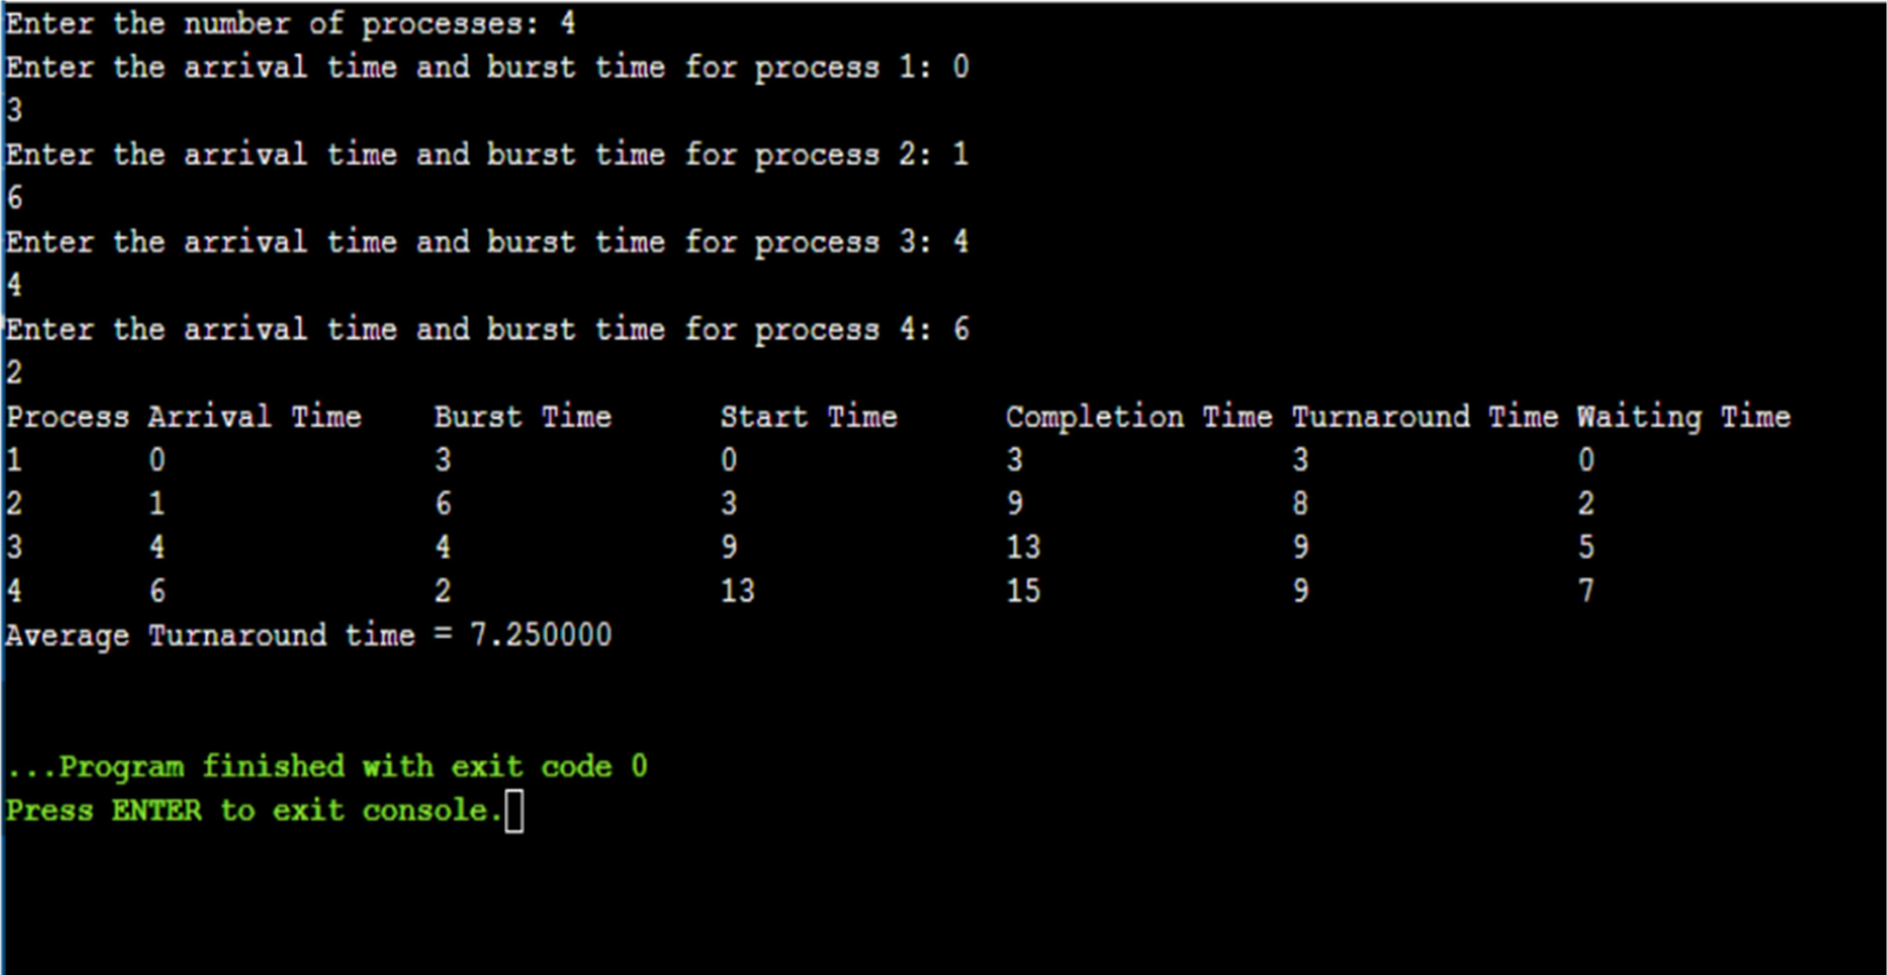

### SJF (pre-emptive & non-pre-emptive)

#include <stdio.h> #include <stdbool.h>

#define MAX_PROCESSES 10

struct Process

{

int pid;

int arr_time; int burst_time; int rem_time; int tat;

int wt;

};

void sjf_nonpreemptive(struct Process p[], int n)

{

int i, j, count = 0, m; for (i = 0; i < n; i++)

{

if (p[i].arr_time == 0) count++;

}

if (count == n || count == 1)

{

if (count == n)

{

for (i = 0; i < n - 1; i++)

{

for (j = 0; j < n - i - 1; j++)

{

if (p[j].burst_time > p[j + 1].burst_time)

{

struct Process temp = p[j]; p[j] = p[j + 1];

p[j + 1] = temp;

}

}

}

}

else

{

for (i = 1; i < n - 1; i++)

{

for (j = 1; j <= n - i - 1; j++)

{

if (p[j].burst_time > p[j + 1].burst_time)

{

struct Process temp = p[j]; p[j] = p[j + 1];

p[j + 1] = temp;

}

}

}

}

}

int total_time = 0; double total_tat = 0; double total_wt = 0;

for (i = 0; i < n; i++)

{

total_time += p[i].burst_time; p[i].tat = total_time - p[i].arr_time; p[i].wt = p[i].tat - p[i].burst_time;

total_tat += p[i].tat; total_wt += p[i].wt;

}

printf("Process\tTurnaround Time\tWaiting Time\n"); for (i = 0; i < n; i++)

{

printf("%d\t%d\t\t%d\n", p[i].pid, p[i].tat, p[i].wt);

}

printf("Average Turnaround Time: %.2f\n", total_tat / n); printf("Average Waiting Time: %.2f\n", total_wt / n);

}

void sjf_preemptive(struct Process p[], int n)

{

int total_time = 0, i; int completed = 0;

while (completed < n)

{

int shortest_burst = -1; int next_process = -1;

for (i = 0; i < n; i++)

{

if (p[i].arr_time <= total_time && p[i].rem_time > 0)

{

if (shortest_burst == -1 || p[i].rem_time < shortest_burst)

{

shortest_burst = p[i].rem_time; next_process = i;

}

}

}

if (next_process == -1)

{

total_time++; continue;

}

p[next_process].rem_time--; total_time++;

if (p[next_process].rem_time == 0)

{

completed++;

p[next_process].tat = total_time - p[next_process].arr_time; p[next_process].wt = p[next_process].tat - p[next_process].burst_time;

}

}

double total_tat = 0; double total_wt = 0;

printf("Process\tTurnaround Time\tWaiting Time\n"); for (i = 0; i < n; i++)

{

printf("%d\t%d\t\t%d\n", p[i].pid, p[i].tat, p[i].wt); total_tat += p[i].tat;

total_wt += p[i].wt;

}

printf("Average Turnaround Time: %.2f\n", total_tat / n); printf("Average Waiting Time: %.2f\n", total_wt / n);

}

int main()

{

int n, quantum, i, choice;

struct Process p[MAX_PROCESSES];

printf("Enter the number of Processes: "); scanf("%d", &n);

for (i = 0; i < n; i++)

{

printf("\nFor Process %d\n", i + 1); printf("Enter Arrival time, Burst Time: ");

scanf("%d%d", &p[i].arr_time, &p[i].burst_time); p[i].pid = i + 1;

p[i].rem_time = p[i].burst_time; p[i].tat = 0;

p[i].wt = 0;

}

printf("\n>> SJF Non-preemptive Scheduling:\n"); sjf_nonpreemptive(p, n);

printf("\n>> SJF Preemptive Scheduling:\n"); sjf_preemptive(p, n);

return 0;

}

# OUTPUT:

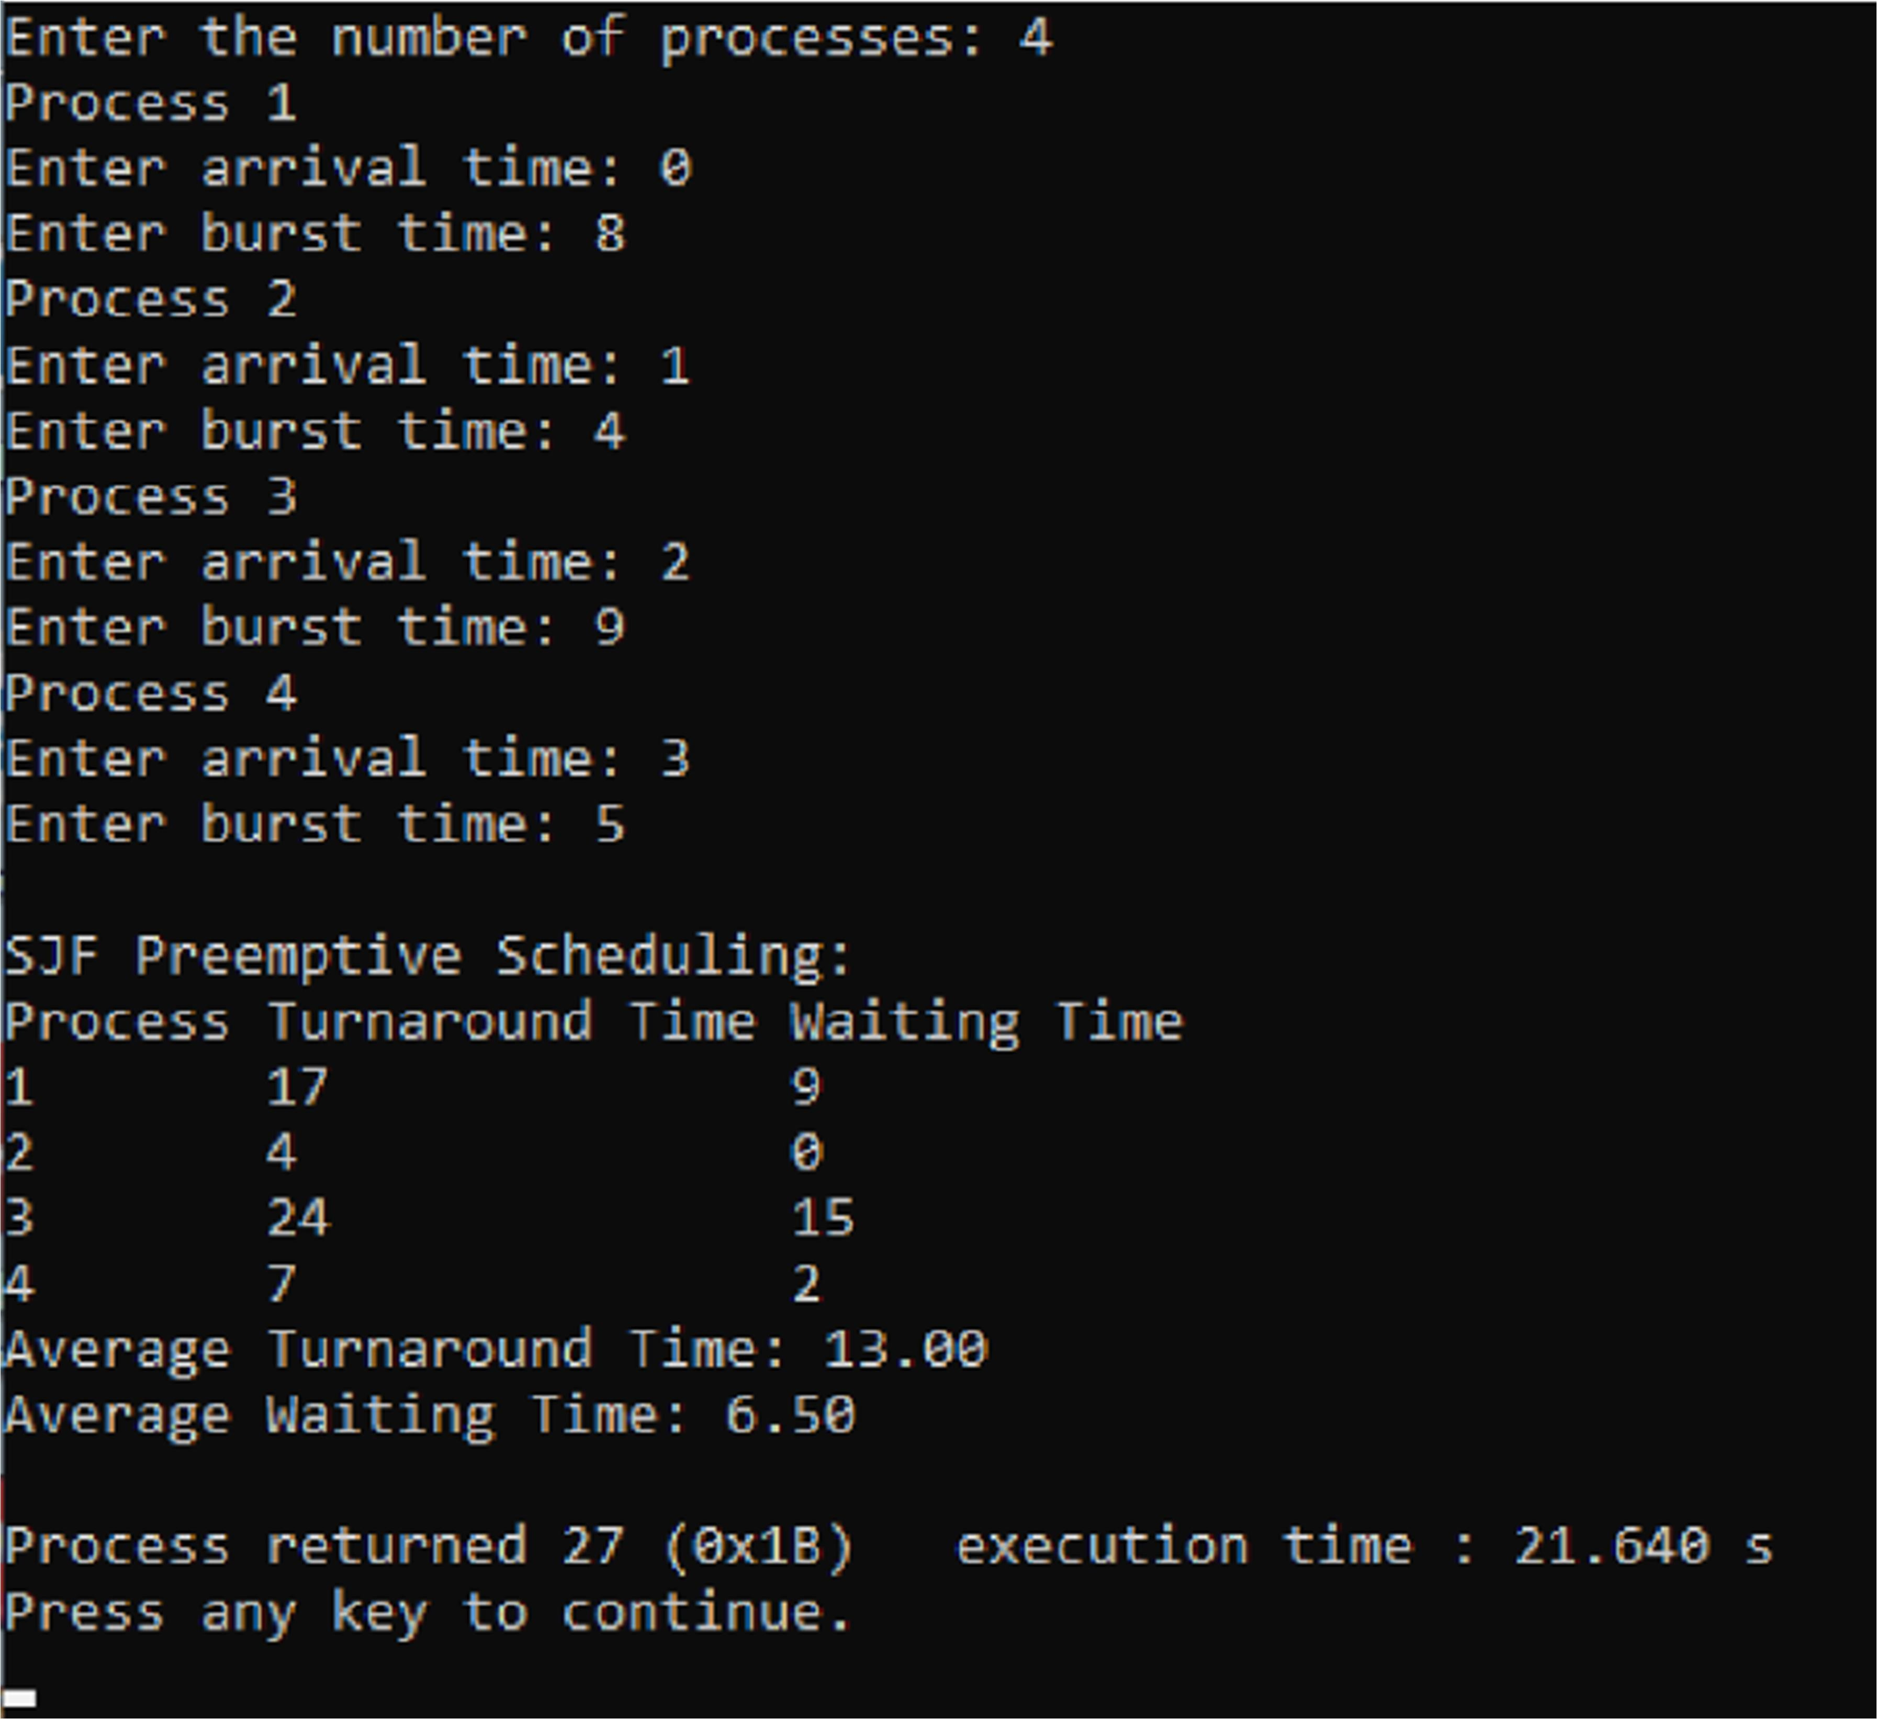

**PROGRAM-2**

## Write a C program to simulate the following CPU scheduling algorithm to find turnaround time and waiting time.

* **Priority (pre-emptive & non-pre-emptive)**

## Round Robin (Experiment with different quantum sizes for RR algorithm)

#include <stdio.h> #include <stdbool.h>

#define MAX_PROCESSES 10

struct Process

{

int pid;

int arr_time; int burst_time; int priority; int rem_time; int tat;

int wt;

};

void priority_nonpreemptive(struct Process p[], int n)

{

int i, j, count = 0, m; for (i = 0; i < n; i++)

{

if (p[i].arr_time == 0)

count++;

}

if (count == n || count == 1)

{

if (count == n)

{

for (i = 0; i < n - 1; i++)

{

for (j = 0; j < n - i - 1; j++)

{

if (p[j].priority > p[j + 1].priority)

{

struct Process temp = p[j]; p[j] = p[j + 1];

p[j + 1] = temp;

}

}

}

}

else

{

for (i = 1; i < n - 1; i++)

{

for (j = 1; j <= n - i - 1; j++)

{

if (p[j].priority > p[j + 1].priority)

{

struct Process temp = p[j]; p[j] = p[j + 1];

p[j + 1] = temp;

}

}

}

}

}

int total_time = 0; double total_tat = 0; double total_wt = 0;

for (i = 0; i < n; i++)

{

total_time += p[i].burst_time; p[i].tat = total_time - p[i].arr_time; p[i].wt = p[i].tat - p[i].burst_time;

total_tat += p[i].tat; total_wt += p[i].wt;

}

printf("Process\tTurnaround Time\tWaiting Time\n"); for (i = 0; i < n; i++)

{

printf("%d\t%d\t\t%d\n", p[i].pid, p[i].tat, p[i].wt);

}

printf("Average Turnaround Time: %.2f\n", total_tat / n); printf("Average Waiting Time: %.2f\n", total_wt / n);

}

void priority_preemptive(struct Process p[], int n)

{

int total_time = 0, i; int completed = 0;

while (completed < n)

{

int highest_priority = -1; int next_process = -1;

for (i = 0; i < n; i++)

{

if (p[i].arr_time <= total_time && p[i].rem_time > 0)

{

if (highest_priority == -1 || p[i].priority < highest_priority)

{

highest_priority = p[i].priority; next_process = i;

}

}

}

if (next_process == -1)

{

total_time++; continue;

}

p[next_process].rem_time--; total_time++;

if (p[next_process].rem_time == 0)

{

completed++;

p[next_process].tat = total_time - p[next_process].arr_time; p[next_process].wt = p[next_process].tat - p[next_process].burst_time;

}

}

double total_tat = 0; double total_wt = 0;

printf("Process\tTurnaround Time\tWaiting Time\n"); for (i = 0; i < n; i++)

{

printf("%d\t%d\t\t%d\n", p[i].pid, p[i].tat, p[i].wt);

total_tat += p[i].tat; total_wt += p[i].wt;

}

printf("Average Turnaround Time: %.2f\n", total_tat / n); printf("Average Waiting Time: %.2f\n", total_wt / n);

}

void round_robin(struct Process p[], int n, int quantum)

{

int total_time = 0, i; int completed = 0;

printf("\nGantt Chart: \n"); while (completed < n)

{

for (i = 0; i < n; i++)

{

if (p[i].arr_time <= total_time && p[i].rem_time > 0)

{

if (p[i].rem_time <= quantum)

{

printf("P%d ", p[i].pid); total_time += p[i].rem_time; p[i].rem_time = 0;

p[i].tat = total_time - p[i].arr_time; p[i].wt = p[i].tat - p[i].burst_time; completed++;

}

else

{

printf("P%d ", p[i].pid); total_time += quantum; p[i].rem_time -= quantum;

}

}

}

}

double total_tat = 0; double total_wt = 0;

printf("\n");

printf("\nProcess\tTurnaround Time\tWaiting Time\n"); for (i = 0; i < n; i++)

{

printf("%d\t%d\t\t%d\n", p[i].pid, p[i].tat, p[i].wt);

total_tat += p[i].tat; total_wt += p[i].wt;

}

printf("Average Turnaround Time: %.2f\n", total_tat / n); printf("Average Waiting Time: %.2f\n", total_wt / n);

}

int main()

{

int n, quantum, i, choice;

struct Process p[MAX_PROCESSES];

printf("Enter the number of Processes: "); scanf("%d", &n);

for (i = 0; i < n; i++)

{

printf("\nFor Process %d\n", i + 1);

printf("Enter Arrival time, Burst Time, Priority:\n"); scanf("%d%d%d",&p[i].arr_time,&p[i].burst_time,&p[i].priority); p[i].pid = i + 1;

p[i].rem_time = p[i].burst_time; p[i].tat = 0;

p[i].wt = 0;

}

printf("\nSelect a scheduling algorithm:\n");

printf("1. Priority (Preemtive & Non-preemptive)\n"); printf("2. Round Robin\n");

printf("Enter your choice: "); scanf("%d", &choice); switch (choice)

{

case 1:

printf("\n>> Priority Non-preemptive Scheduling:\n"); priority_nonpreemptive(p, n);

printf("\n>> Priority Preemptive Scheduling:\n"); priority_preemptive(p, n);

break; case 2:

printf("\nEnter the quantum size for Round Robin: "); scanf("%d", &quantum);

printf("\n>> Round Robin Scheduling (Quantum: %d):\n", quantum); round_robin(p, n, quantum);

break; default:

printf("Invalid choice!\n"); return 1;

}

return 0;

}

# OUTPUT:

## Priority (pre-emptive & non-pre-emptive):

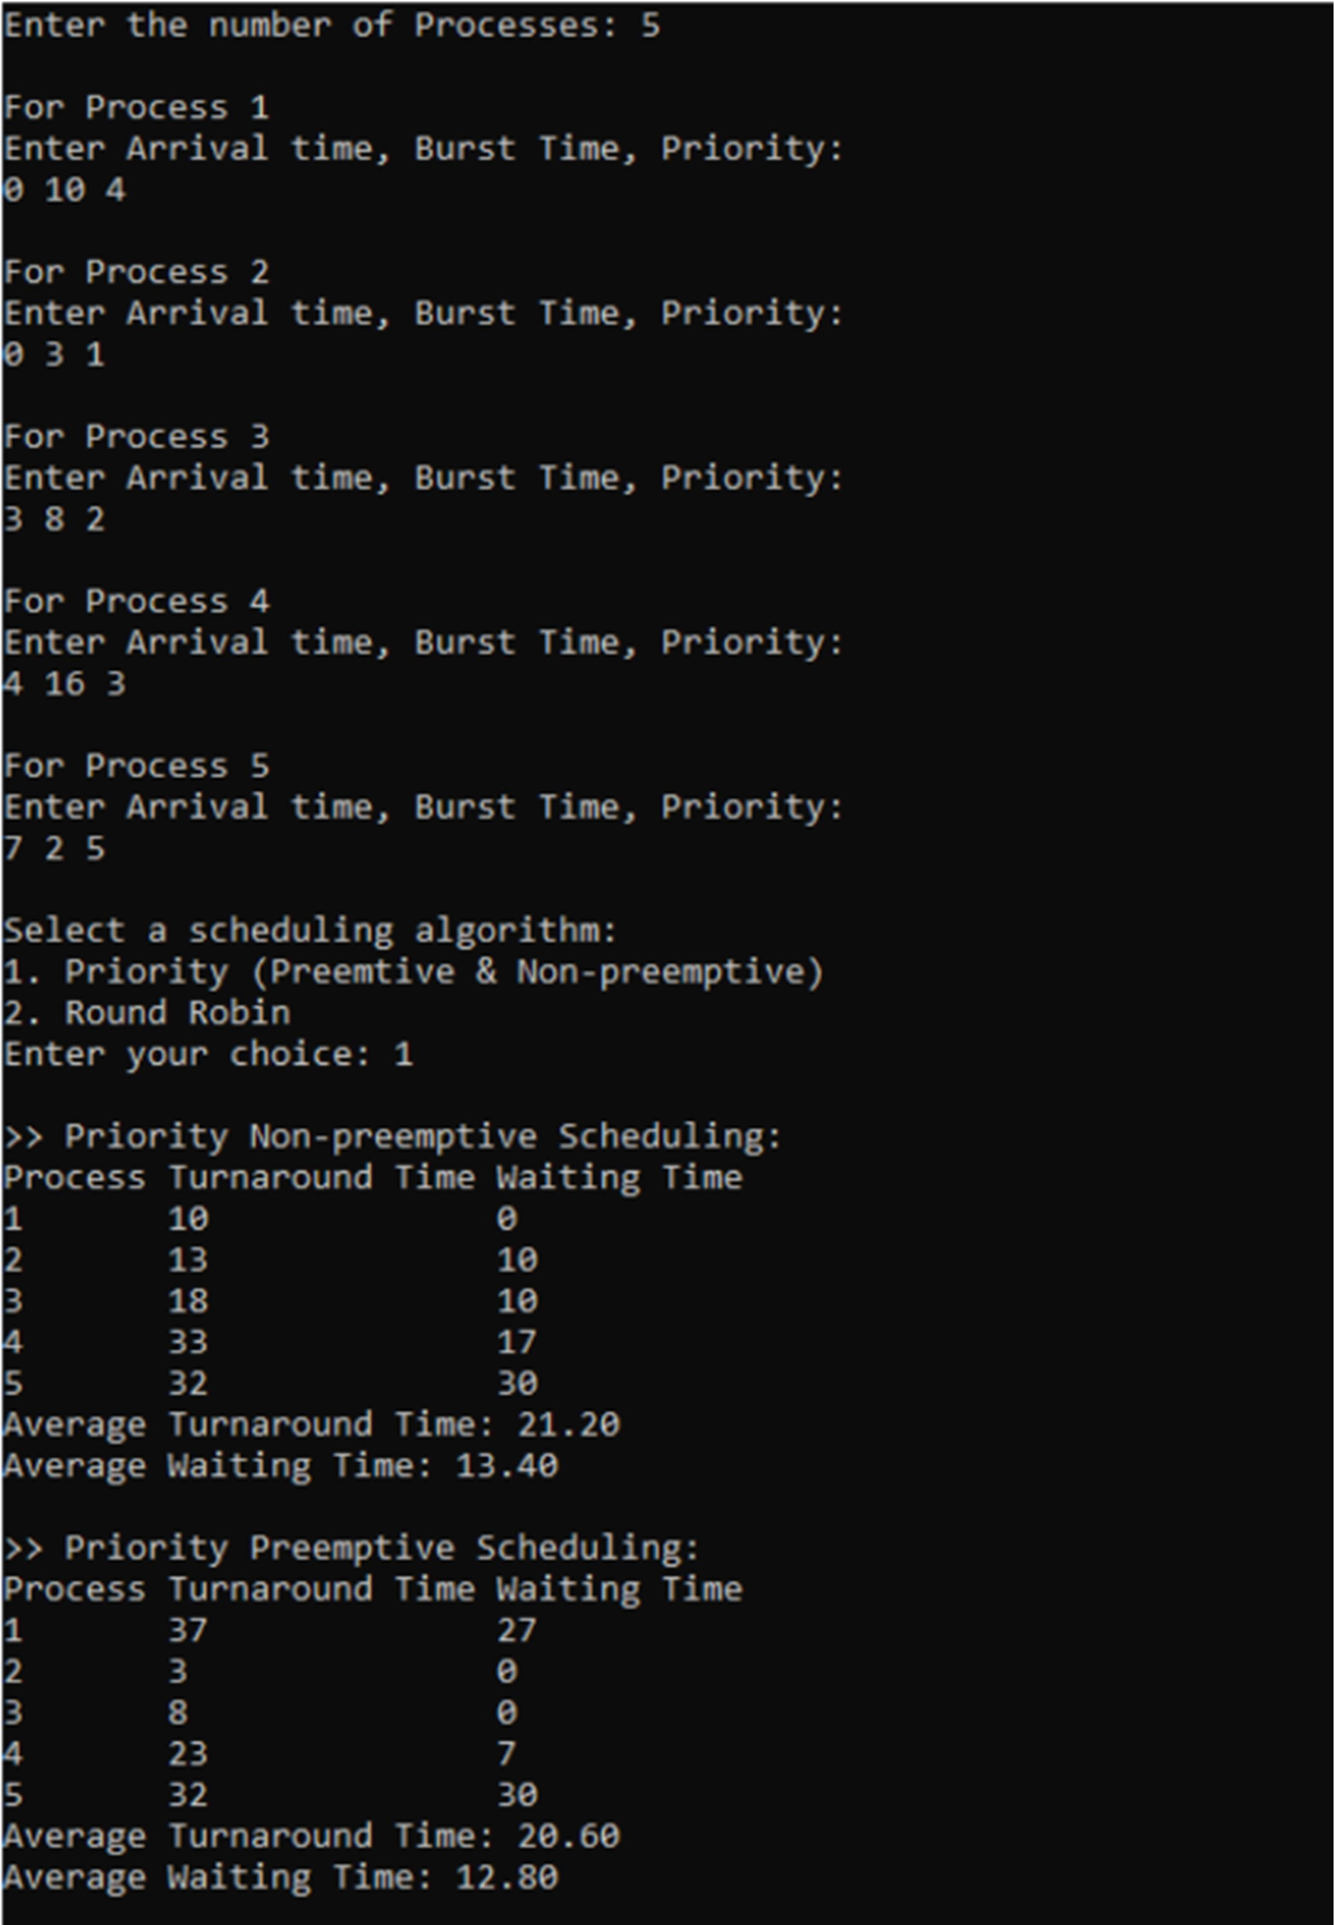

**Round Robin:**

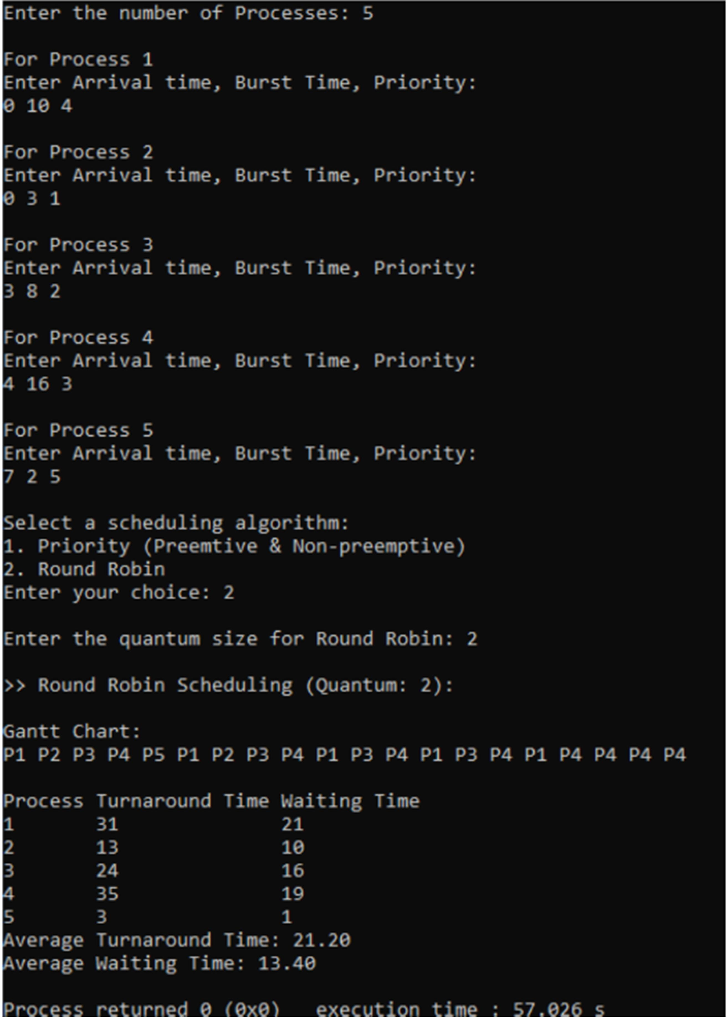

# PROGRAM-3

## Write a C program to simulate multi-level queue scheduling algorithm considering the following scenario. All the processes in the system are divided into two categories – system processes and user processes. System processes are to be given higher priority than user processes. Use FCFS scheduling for the processes in each queue.

#include <stdio.h> #include <stdlib.h>

#define MAX_QUEUE_SIZE 100

int totalTime = 0;

int userProcess = 0, systemProcess = 0;

typedef struct { int processID; int arrivalTime; int burstTime;

int remainingTime;

int priority; // 0 for system process, 1 for user process

} Process;

void executeProcess(Process process) { printf("Executing Process %d\n", process.processID); for (int i = 1; i <= process.burstTime; i++) {

printf("Process %d: %d/%d\n", process.processID, i, process.burstTime);

}

printf("Process %d executed\n", process.processID);

}

void scheduleFCFS(Process system[], Process user[]) { for (int i = 0; i < systemProcess; i++) {

for (int j = i + 1; j < systemProcess; j++) {

if (system[i].arrivalTime > system[j].arrivalTime) { Process temp = system[i];

system[i] = system[j]; system[j] = temp;

}

}

}

for (int i = 0; i < userProcess; i++) {

for (int j = i + 1; j < userProcess; j++) {

if (user[i].arrivalTime > user[j].arrivalTime) { Process temp = user[i];

user[i] = user[j]; user[j] = temp;

}

}

}

int completed = 0;

int currentProcess = -1;

int isUserProcess = 0; // Changed bool to int int size = userProcess + systemProcess; while (1) {

int count = 0;

for (int i = 0; i < systemProcess; i++) { if (system[i].remainingTime <= 0) {

count++;

}

}

for (int j = 0; j < userProcess; j++) { if (user[j].remainingTime <= 0) {

count++;

}

}

if (count == size) {

printf("\n end of processes"); exit(0);

}

for (int i = 0; i < systemProcess; i++) {

if (totalTime >= system[i].arrivalTime && system[i].remainingTime > 0) { currentProcess = i;

isUserProcess = 0; // Changed true to 0 break;

}

}

if (currentProcess == -1) {

for (int j = 0; j < userProcess; j++) {

if (totalTime >= user[j].arrivalTime && user[j].remainingTime > 0) { currentProcess = j;

isUserProcess = 1; // Changed true to 1 break;

}

}

}

if (currentProcess == -1) {

totalTime++;

printf("\n %d idle time...", totalTime); if (totalTime == 1000) {

exit(0);

}

continue;

}

if (isUserProcess == 1) { // Changed true to 1 user[currentProcess].remainingTime--;

printf("\n User process %d will execute at %d ", user[currentProcess].processID, (totalTime));

totalTime++;

isUserProcess = 0; // Changed true to 0 currentProcess = -1;

if (user[currentProcess].remainingTime == 0) { completed++;

}

} else {

int temp = totalTime;

while (system[currentProcess].remainingTime--) { totalTime++;

}

if (system[currentProcess].remainingTime == 0) { completed++;

}

printf("\n System process %d will execute from %d to %d ", system[currentProcess].processID, temp, (totalTime));

isUserProcess = 0; // Changed true to 0 currentProcess = -1;

}

}

}

int main() {

int numProcesses;

Process processes[MAX_QUEUE_SIZE];

// Reading the number of processes printf("Enter the number of processes: "); scanf("%d", &numProcesses);

// Reading process details

for (int i = 0; i < numProcesses; i++) { printf("Process %d:\n", i + 1); printf("Arrival Time: ");

scanf("%d", &processes[i].arrivalTime); printf("Burst Time: ");

scanf("%d", &processes[i].burstTime); printf("System(0)/User(1): "); scanf("%d", &processes[i].priority); processes[i].processID = i + 1;

processes[i].remainingTime = processes[i].burstTime; if (processes[i].priority == 1) {

userProcess++;

} else {

systemProcess++;

}

}

Process systemQueue[MAX_QUEUE_SIZE]; int systemQueueSize = 0;

Process userQueue[MAX_QUEUE_SIZE]; int userQueueSize = 0;

for (int i = 0; i < numProcesses; i++) { if (processes[i].priority == 0) {

systemQueue[systemQueueSize++] = processes[i];

} else {

userQueue[userQueueSize++] = processes[i];

}

}

printf("Order of Execution:\n"); scheduleFCFS(systemQueue, userQueue); return 0;

}

# OUTPUT:

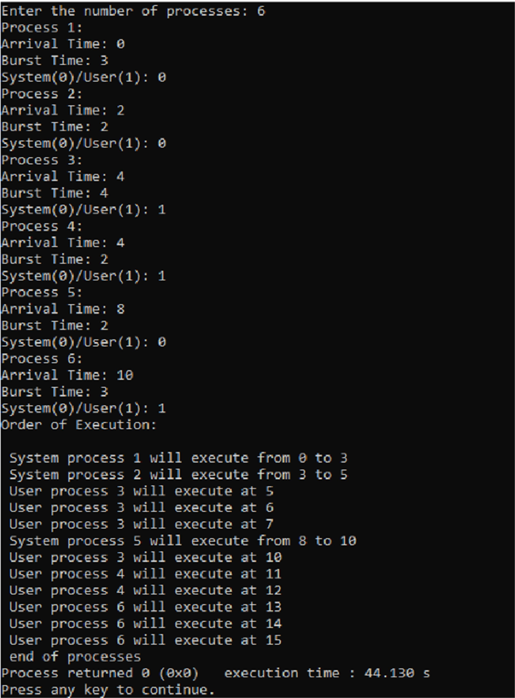

**PROGRAM-4**

## Write a C program to simulate Real-Time CPU Scheduling algorithms:

1. **Rate- Monotonic**

## Earliest-deadline First

1. ***Rate- Monotonic*** #include <stdio.h> #include <math.h> #include <stdlib.h>

#define MAX_PROCESS 10

int num_of_process = 3;

int execution_time[MAX_PROCESS], period[MAX_PROCESS], remain_time[MAX_PROCESS];

// collecting details of processes void get_process_info()

{

printf("Enter total number of processes (maximum %d): ", MAX_PROCESS); scanf("%d", &num_of_process);

if (num_of_process < 1)

{

printf("Do you really want to schedule %d processes? -_-\n", num_of_process); exit(0);

}

for (int i = 0; i < num_of_process; i++)

{

printf("\nProcess %d:-\n", i + 1);

printf("==> Execution time: "); scanf("%d", &execution_time[i]); remain_time[i] = execution_time[i];

printf("==> Period: "); scanf("%d", &period[i]);

}

}

// get maximum of three numbers int max(int a, int b, int c)

{

if (a >= b && a >= c) return a;

else if (b >= a && b >= c) return b;

else

return c;

}

// calculating the observation time for scheduling timeline int get_observation_time()

{

return max(period[0], period[1], period[2]);

}

// print scheduling sequence

void print_schedule(int process_list[], int cycles)

{

printf("\nScheduling:-\n\n"); printf("Time: ");

for (int i = 0; i < cycles; i++)

{

if (i < 9)

printf("| 0%d ", i + 1); else

printf("| %d ", i + 1);

}

printf("|\n");

for (int i = 0; i < num_of_process; i++)

{

printf("P[%d]: ", i + 1);

for (int j = 0; j < cycles; j++)

{

if (process_list[j] == i + 1) printf("|####");

else

printf("| ");

}

printf("|\n");

}

}

void rate_monotonic(int time)

{

float utilization = 0;

for (int i = 0; i < num_of_process; i++)

{

utilization += (1.0 * execution_time[i]) / period[i];

}

int n = num_of_process;

if (utilization > n * (pow(2, 1.0 / n) - 1))

{

printf("\nGiven problem is not schedulable under said scheduling algorithm.\n"); exit(0);

}

int process_list[time];

int min = 999, next_process = 0; for (int i = 0; i < time; i++)

{

min = 1000;

for (int j = 0; j < num_of_process; j++)

{

if (remain_time[j] > 0)

{

if (min > period[j])

{

min = period[j]; next_process = j;

}

}

}

if (remain_time[next_process] > 0)

{

process_list[i] = next_process + 1; // +1 for catering 0 array index. remain_time[next_process] -= 1;

}

for (int k = 0; k < num_of_process; k++)

{

if ((i + 1) % period[k] == 0)

{

remain_time[k] = execution_time[k]; next_process = k;

}

}

}

print_schedule(process_list, time);

}

int main(int argc, char *argv[])

{

printf("Rate Monotonic Scheduling\n"); printf(" \n");

get_process_info(); // collecting processes detail int observation_time = get_observation_time(); rate_monotonic(observation_time);

return 0;

}

# OUTPUT:

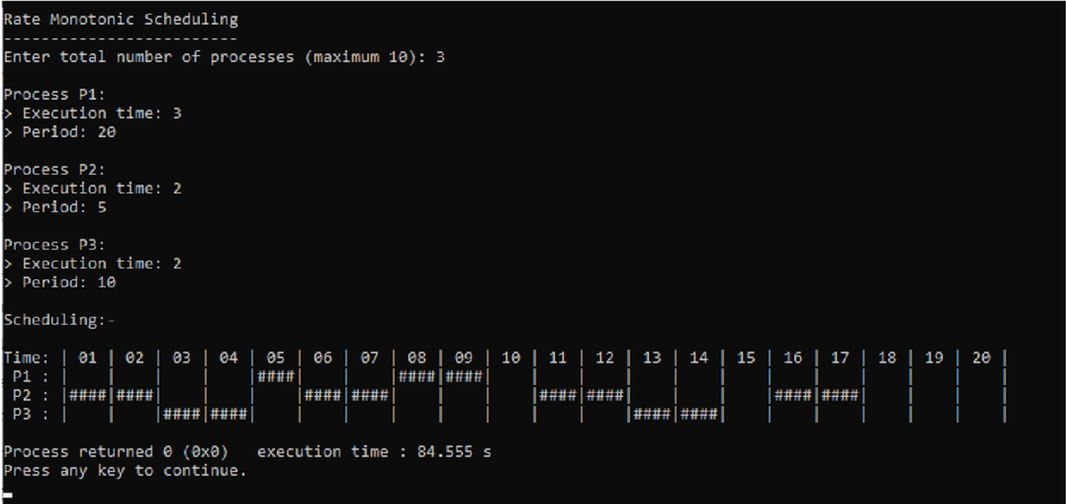

1. ***Earliest-Deadline First*** #include <stdio.h> #include <malloc.h>

#define arrival 0

#define execution 1

#define deadline 2

#define period 3

#define abs_arrival 4

#define execution_copy 5

#define abs_deadline 6

typedef struct

{

int T[7], instance, alive;

} task;

#define IDLE_TASK_ID 1023

#define ALL 1

#define CURRENT 0

void get_tasks(task *t1, int n);

int hyperperiod_calc(task *t1, int n); float cpu_util(task *t1, int n);

int gcd(int a, int b); int lcm(int *a, int n);

int sp_interrupt(task *t1, int tmr, int n);

int min(task *t1, int n, int p);

void update_abs_arrival(task *t1, int n, int k, int all); void update_abs_deadline(task *t1, int n, int all); void copy_execution_time(task *t1, int n, int all);

int timer = 0;

int main()

{

task *t;

int n, hyper_period, active_task_id; float cpu_utilization;

printf("Enter number of tasks\n"); scanf("%d", &n);

t = (task *)malloc(n * sizeof(task)); get_tasks(t, n);

cpu_utilization = cpu_util(t, n);

printf("CPU Utilization %f\n", cpu_utilization);

if (cpu_utilization < 1)

printf("Tasks can be scheduled\n"); else

printf("Schedule is not feasible\n");

hyper_period = hyperperiod_calc(t, n); copy_execution_time(t, n, ALL); update_abs_arrival(t, n, 0, ALL); update_abs_deadline(t, n, ALL);

while (timer < hyper_period)

{

++timer;

if (timer < 10)

printf("| %d", timer); else

printf("| %d", timer);

}

printf("|\n");

timer = 0;

while (timer < hyper_period)

{

if (sp_interrupt(t, timer, n))

{

active_task_id = min(t, n, abs_deadline);

}

if (active_task_id == IDLE_TASK_ID)

{

printf("|Idl");

}

if (active_task_id != IDLE_TASK_ID)

{

if (t[active_task_id].T[execution_copy] != 0)

{

t[active_task_id].T[execution_copy]--; printf("|T-%d", active_task_id + 1);

}

if (t[active_task_id].T[execution_copy] == 0)

{

t[active_task_id].instance++; t[active_task_id].alive = 0;

copy_execution_time(t, active_task_id, CURRENT);

update_abs_arrival(t, active_task_id, t[active_task_id].instance, CURRENT); update_abs_deadline(t, active_task_id, CURRENT);

active_task_id = min(t, n, abs_deadline);

}

}

++timer;

}

printf("|\n"); free(t); return 0;

}

void get_tasks(task *t1, int n)

{

int i = 0; while (i < n)

{

printf("Enter Task %d parameters\n", i + 1); t1->T[arrival] = 0;

printf("Execution time: "); scanf("%d", &t1->T[execution]); printf("Deadline time: "); scanf("%d", &t1->T[deadline]); printf("Period: ");

scanf("%d", &t1->T[period]); t1->T[abs_arrival] = 0;

t1->T[execution_copy] = 0;

t1->T[abs_deadline] = 0;

t1->instance = 0;

t1->alive = 0; t1++;

i++;

}

}

int hyperperiod_calc(task *t1, int n)

{

int i = 0, ht, a[10]; while (i < n)

{

a[i] = t1->T[period]; t1++;

i++;

}

ht = lcm(a, n);

return ht;

}

int gcd(int a, int b)

{

if (b == 0) return a;

else

return gcd(b, a % b);

}

int lcm(int *a, int n)

{

int res = 1, i;

for (i = 0; i < n; i++)

{

res = res * a[i] / gcd(res, a[i]);

}

return res;

}

int sp_interrupt(task *t1, int tmr, int n)

{

int i = 0, n1 = 0, a = 0; task *t1_copy; t1_copy = t1;

while (i < n)

{

if (tmr == t1->T[abs_arrival])

{

t1->alive = 1; a++;

}

t1++; i++;

}

t1 = t1_copy; i = 0;

while (i < n)

{

if (t1->alive == 0) n1++;

t1++; i++;

}

if (n1 == n || a != 0)

{

return 1;

}

return 0;

}

void update_abs_deadline(task *t1, int n, int all)

{

int i = 0; if (all)

{

while (i < n)

{

t1->T[abs_deadline] = t1->T[deadline] + t1->T[abs_arrival]; t1++;

i++;

}

}

else

{

t1 += n;

t1->T[abs_deadline] = t1->T[deadline] + t1->T[abs_arrival];

}

}

void update_abs_arrival(task *t1, int n, int k, int all)

{

int i = 0; if (all)

{

while (i < n)

{

t1->T[abs_arrival] = t1->T[arrival] + k * (t1->T[period]); t1++;

i++;

}

}

else

{

t1 += n;

t1->T[abs_arrival] = t1->T[arrival] + k * (t1->T[period]);

}

}

void copy_execution_time(task *t1, int n, int all)

{

int i = 0; if (all)

{

while (i < n)

{

t1->T[execution_copy] = t1->T[execution]; t1++;

i++;

}

}

else

{

t1 += n;

t1->T[execution_copy] = t1->T[execution];

}

}

int min(task *t1, int n, int p)

{

int i = 0, min = 0x7FFF, task_id = IDLE_TASK_ID; while (i < n)

{

if (min > t1->T[p] && t1->alive == 1)

{

min = t1->T[p]; task_id = i;

}

t1++; i++;

}

return task_id;

}

float cpu_util(task *t1, int n)

{

int i = 0; float cu = 0; while (i < n)

{

cu = cu + (float)t1->T[execution] / (float)t1->T[deadline]; t1++;

i++;

}

return cu;

}

# OUTPUT:

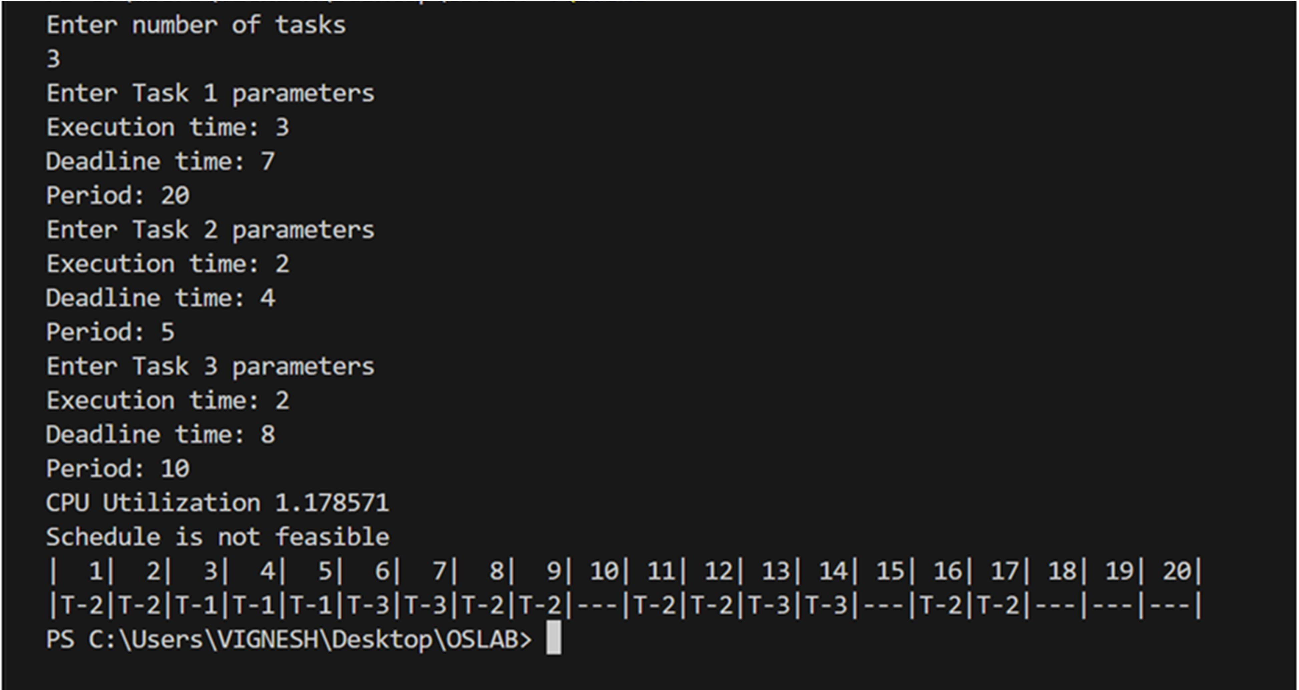

**PROGRAM-5**

## Write a C program to simulate producer-consumer problem using semaphores.

#include <stdio.h> #include <conio.h> #include <stdlib.h>

int mutex = 1; int full = 0;

int empty = 10; int count = 0;

int wait(int s)

{

while (s <= 0)

; s--;

return s;

}

int signal(int s)

{

s++;

return s;

}

void producer()

{

empty = wait(empty); mutex = wait(mutex); count++;

printf("Producer produces an item %d\n", count); mutex = signal(mutex);

full = signal(full);

}

void consumer()

{

full = wait(full); mutex = wait(mutex);

printf("Consumer consumes an item %d\n", count); count--;

mutex = signal(mutex); empty = signal(empty);

}

void main()

{

int choice;

printf("\n>Enter 1 for Producer\n>Enter 2 for Consumer\n>Enter 3 for Exit\n"); while (1)

{

printf("\nEnter your choice: "); scanf("%d", &choice);

switch (choice)

{

case 1:

if (empty == 0)

{

printf("\nBuffer is full!!\n");

}

else

{

producer();

}

break; case 2:

if (full == 0)

{

printf("\nBuffer is empty!!\n");

}

else

{

consumer();

}

break; case 3:

exit(0); break;

default:

printf("Invalid choice\n");

}

}

}

# OUTPUT:

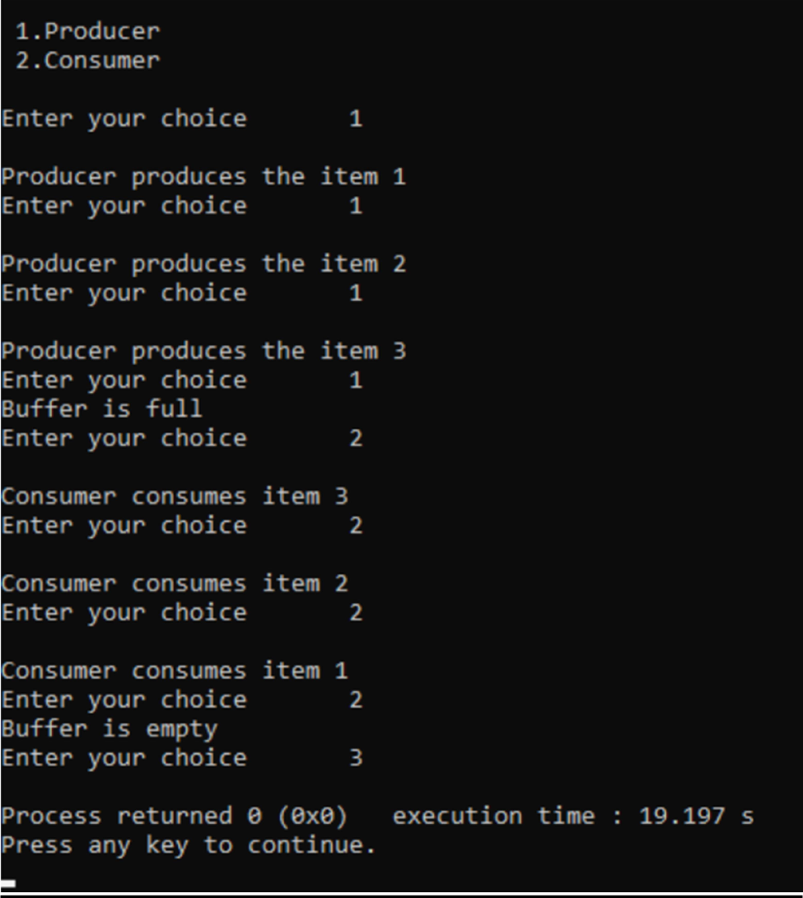

**PROGRAM-6**

## Write a C program to simulate the concept of Dining-Philosophers problem.

#include <pthread.h> #include <semaphore.h> #include <stdio.h>

#define N 5

#define THINKING 2

#define HUNGRY 1

#define EATING 0

#define LEFT (phnum + 4) % N #define RIGHT (phnum + 1) % N

int state[N];

int phil[N] = {0, 1, 2, 3, 4};

sem_t mutex; sem_t S[N];

void test(int phnum)

{

if (state[phnum] == HUNGRY && state[LEFT] != EATING && state[RIGHT] != EATING)

{

state[phnum] = EATING; sleep(2);

printf("Philosopher %d takes fork %d and %d\n", phnum + 1, LEFT + 1, phnum + 1); printf("Philosopher %d is Eating\n", phnum + 1);

sem_post(&S[phnum]);

}

}

void take_fork(int phnum)

{

sem_wait(&mutex); state[phnum] = HUNGRY;

printf("Philosopher %d is Hungry\n", phnum + 1); test(phnum);

sem_post(&mutex); sem_wait(&S[phnum]); sleep(1);

}

void put_fork(int phnum)

{

sem_wait(&mutex); state[phnum] = THINKING;

printf("Philosopher %d putting fork %d and %d down\n", phnum + 1, LEFT + 1, phnum + 1); printf("Philosopher %d is thinking\n", phnum + 1);

test(LEFT); test(RIGHT); sem_post(&mutex);

}

void *philosopher(void *num)

{

while (1)

{

int *i = num; sleep(1); take_fork(*i); sleep(0); put_fork(*i);

}

}

int main()

{

int i;

pthread_t thread_id[N]; sem_init(&mutex, 0, 1);

for (i = 0; i < N; i++) sem_init(&S[i], 0, 0);

for (i = 0; i < N; i++)

{

pthread_create(&thread_id[i], NULL, philosopher, &phil[i]); printf("Philosopher %d is thinking\n", i + 1);

}

for (i = 0; i < N; i++) pthread_join(thread_id[i], NULL);

}

# OUTPUT:

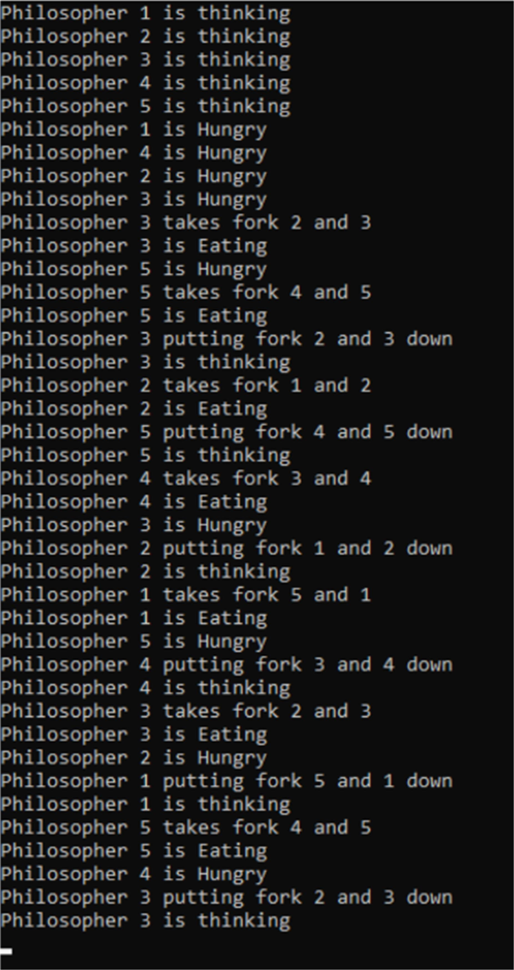

**PROGRAM-7**

## Write a C program to simulate Banker’s algorithm for the purpose of deadlock avoidance.

#include <stdio.h> #include <stdlib.h>

int main()

{

int N, M = 3, ind = 0;

printf("\nEnter the number of processess: "); scanf("%d", &N);

printf("Enter the number of resources: "); scanf("%d", &M);

int alloc[N][M], max[N][M], need[N][M], finished[N], ans[N], avail[M];

printf("\nEnter allocated resources\n"); for (int i = 0; i < N; i++)

{

printf("For Process %d: ", i); for (int j = 0; j < M; j++)

{

scanf("%d", &alloc[i][j]);

}

}

printf("\nEnter Maximum resources\n"); for (int i = 0; i < N; i++)

{

printf("For Process %d: ", i); for (int j = 0; j < M; j++)

{

scanf("%d", &max[i][j]);

}

}

printf("\nEnter available resources\n"); for (int i = 0; i < M; i++)

{

scanf("%d", &avail[i]);

}

for (int i = 0; i < N; i++)

{

finished[i] = 0;

}

for (int i = 0; i < N; i++)

{

for (int j = 0; j < M; j++)

{

need[i][j] = max[i][j] - alloc[i][j];

}

}

for (int k = 0; k < N; k++)

{

for (int i = 0; i < N; i++)

{

if (finished[i] == 0)

{

int flag = 0;

for (int j = 0; j < M; j++)

{

if (need[i][j] > avail[j])

{

flag = 1; break;

}

}

if (flag == 0)

{

ans[ind++] = i;

for (int p = 0; p < M; p++)

{

avail[p] += alloc[i][p];

}

finished[i] = 1;

}

}

}

}

printf("\nProcess\tAllocation\tMax\tNeed\tAvailable"); for (int i = 0; i < N; i++)

{

printf("\n P%d: \t", i);

for (int j = 0; j < M; j++) printf("%d ", alloc[i][j]);

printf("\t\t");

for (int j = 0; j < M; j++) printf("%d ", max[i][j]);

printf("\t");

for (int j = 0; j < M; j++) printf("%d ", need[i][j]);

printf("\t");

if (i == 0)

{

for (int j = 0; j < M; j++) printf("%d ", avail[j]);

}

}

int flag = 1;

for (int i = 0; i < N; i++)

{

if (finished[i] == 0)

{

flag = 0;

printf("\n\nThe System is NOT in safe state(DeadLock Detected)\n"); break;

}

}

if (flag == 1)

{

printf("\n\n--No DeadLock--\nSafe Sequence:\n"); for (int i = 0; i < N - 1; i++)

{

printf("P%d --> ", ans[i]);

}

printf("P%d\n", ans[N - 1]);

}

}

# OUTPUT:

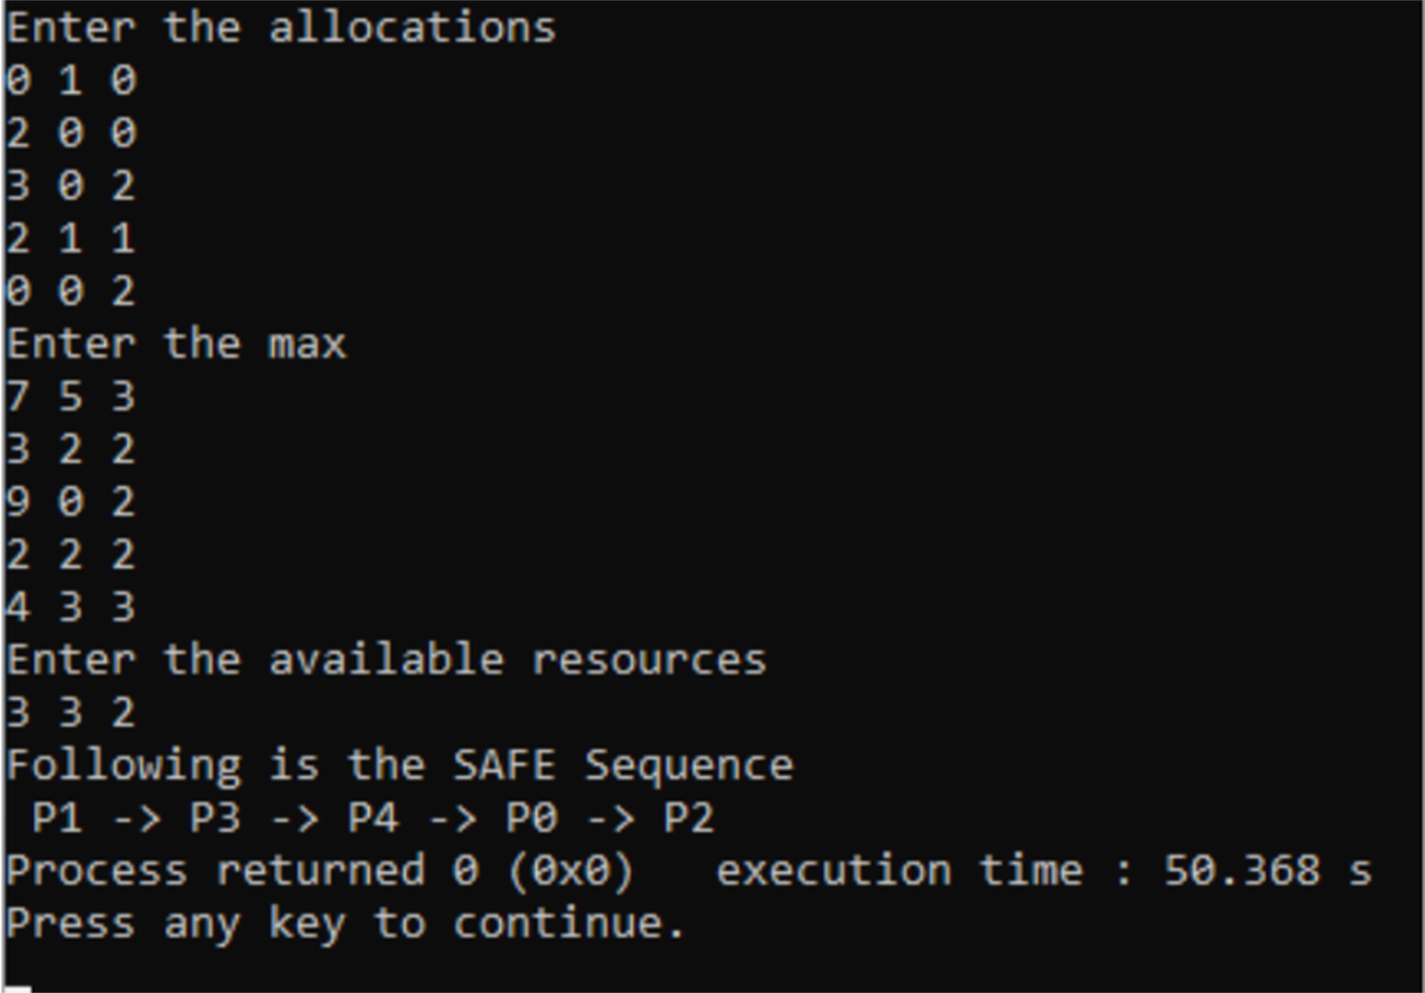

**PROGRAM-8**

## Write a C program to simulate deadlock detection.

#include <stdio.h> #include <stdlib.h>

int main()

{

int N, M, ind = 0;

printf("\nEnter the number of processess: "); scanf("%d", &N);

printf("Enter the number of resources: "); scanf("%d", &M);

int alloc[N][M], max[N][M], need[N][M], finished[N], ans[N], avail[M];

printf("\nEnter allocated resources\n"); for (int i = 0; i < N; i++)

{

printf("For Process %d: ", i); for (int j = 0; j < M; j++)

{

scanf("%d", &alloc[i][j]);

}

}

printf("\nEnter Maximum resources\n"); for (int i = 0; i < N; i++)

{

printf("For Process %d: ", i); for (int j = 0; j < M; j++)

{

scanf("%d", &max[i][j]);

}

}

printf("\nEnter available resources\n"); for (int i = 0; i < M; i++)

{

scanf("%d", &avail[i]);

}

for (int i = 0; i < N; i++)

{

finished[i] = 0;

}

for (int i = 0; i < N; i++)

{

for (int j = 0; j < M; j++)

{

need[i][j] = max[i][j] - alloc[i][j];

}

}

for (int k = 0; k < N; k++)

{

for (int i = 0; i < N; i++)

{

if (finished[i] == 0)

{

int flag = 0;

for (int j = 0; j < M; j++)

{

if (need[i][j] > avail[j])

{

flag = 1; break;

}

}

if (flag == 0)

{

ans[ind++] = i;

for (int p = 0; p < M; p++)

{

avail[p] += alloc[i][p];

}

finished[i] = 1;

}

}

}

}

int flag = 1;

for (int i = 0; i < N; i++)

{

if (finished[i] == 0)

{

flag = 0;

printf("\nSystem is in a DeadLock state.\n"); break;

}

}

if (flag == 1)

{

printf("\nSystem is in a safe state(No DeadLock).\n");

}

}

# OUTPUT:

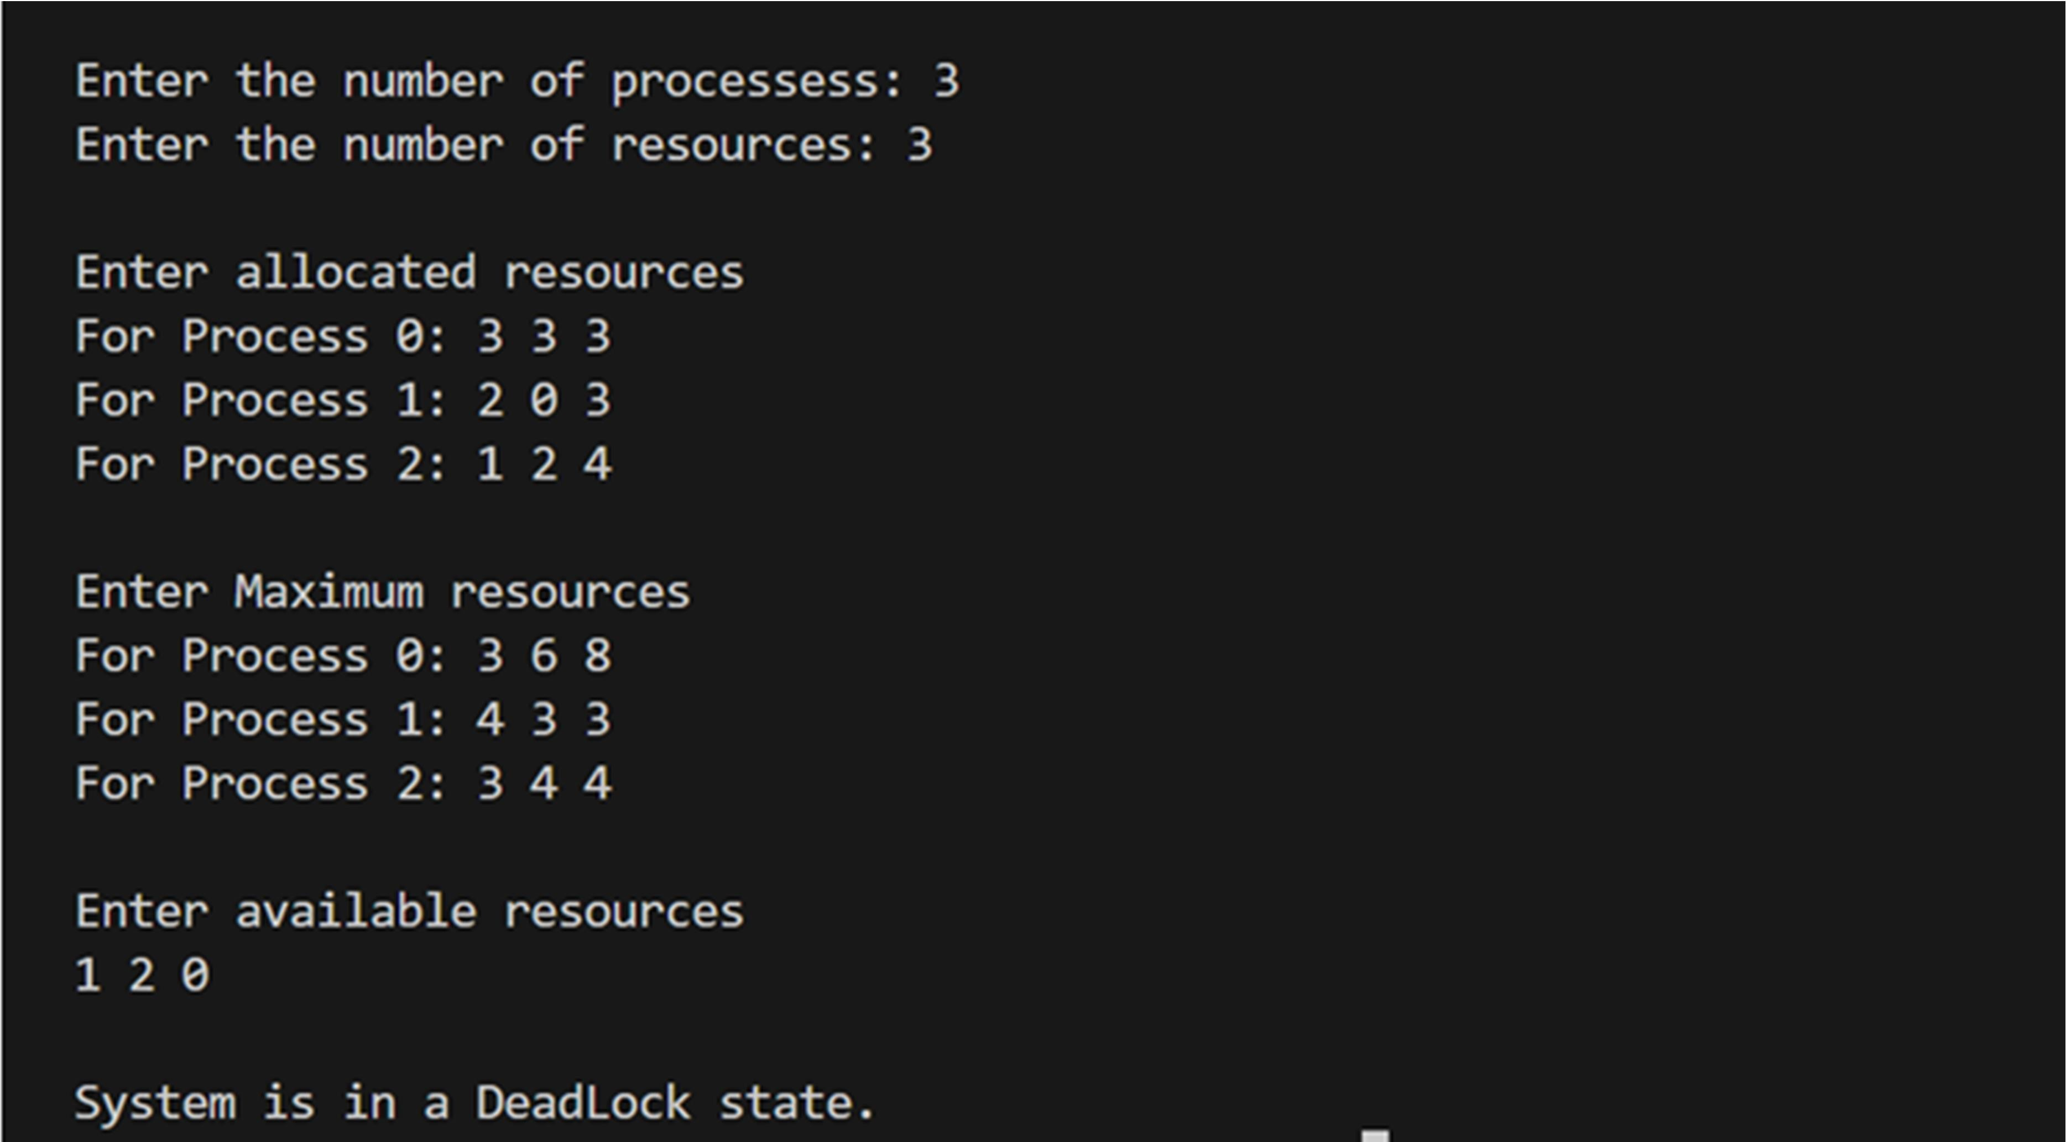

**PROGRAM-9**

## Write a C program to simulate the following contiguous memory allocation techniques

1. **Worst-fit**

## Best-fit

1. **First-fit**

#include <stdio.h> #define max 25

int frag[max], b[max], f[max], i, j, nb, nf, temp, highest = 0, lowest = 10000, ch; static int bf[max], ff[max];

void firstfit(); void bestfit(); void worstfit();

void main()

{

printf("\n\t Memory Management Scheme\n"); printf("\t ");

printf("\nEnter the number of blocks: "); scanf("%d", &nb);

printf("Enter the number of files: "); scanf("%d", &nf);

printf("\nEnter the size of the blocks\n"); for (i = 1; i <= nb; i++)

{

printf("Block %d: ", i);

scanf("%d", &b[i]);

}

printf("\nEnter the size of the files\n"); for (i = 1; i <= nf; i++)

{

printf("File %d: ", i);

scanf("%d", &f[i]);

}

printf("\n1.First Fit || 2.Best Fit || 3.Worst Fit ||\nEnter the Allocation Technique: "); scanf("%d", &ch);

switch (ch)

{

case 1:

firstfit(); break;

case 2:

bestfit(); break;

case 3:

worstfit(); break;

default:

printf("Invalid choice");

}

}

void firstfit()

{

for (i = 1; i <= nf; i++)

{

for (j = 1; j <= nb; j++)

{

if (bf[j] != 1)

{

temp = b[j] - f[i]; if (temp >= 0)

{

ff[i] = j; break;

}

}

}

frag[i] = temp; bf[ff[i]] = 1;

}

printf("\nFile No\tFile Size\tBlock No\tBlock Size\tFragement"); for (i = 1; i <= nf; i++)

printf("\nF%d\t%d\t\t%d\t\t%d\t\t%d", i, f[i], ff[i], b[ff[i]], frag[i]);

}

void bestfit()

{

for (i = 1; i <= nf; i++)

{

for (j = 1; j <= nb; j++)

{

if (bf[j] != 1)

{

temp = b[j] - f[i]; if (temp >= 0)

if (lowest > temp)

{

ff[i] = j; lowest = temp;

}

}

}

frag[i] = lowest; bf[ff[i]] = 1;

lowest = 10000;

}

printf("\nFile No\tFile Size \tBlock No\tBlock Size\tFragment"); for (i = 1; i <= nf && ff[i] != 0; i++)

printf("\nF%d\t\t%d\t\t%d\t\t%d\t\t%d", i, f[i], ff[i], b[ff[i]], frag[i]);

}

void worstfit()

{

for (i = 1; i <= nf; i++)

{

for (j = 1; j <= nb; j++)

{

if (bf[j] != 1)

{

temp = b[j] - f[i]; if (temp >= 0)

if (highest < temp)

{

ff[i] = j; highest = temp;

}

}

}

frag[i] = highest; bf[ff[i]] = 1;

highest = 0;

}

printf("\nFile No\tFile Size\tBlock No\tBlock Size\tFragement"); for (i = 1; i <= nf; i++)

printf("\nF%d\t\t%d\t\t%d\t\t%d\t\t%d", i, f[i], ff[i], b[ff[i]], frag[i]);

}

# OUTPUT:

1. **Worst-fit**

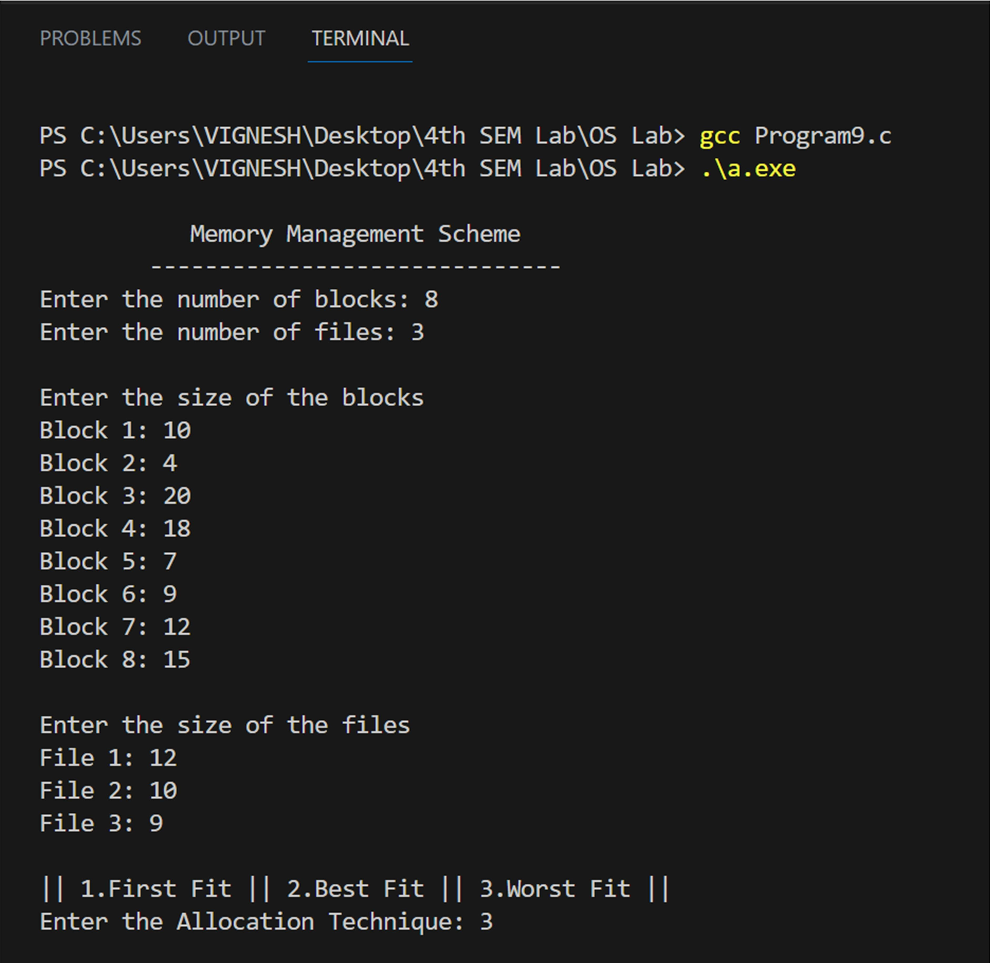

# Best-Fit

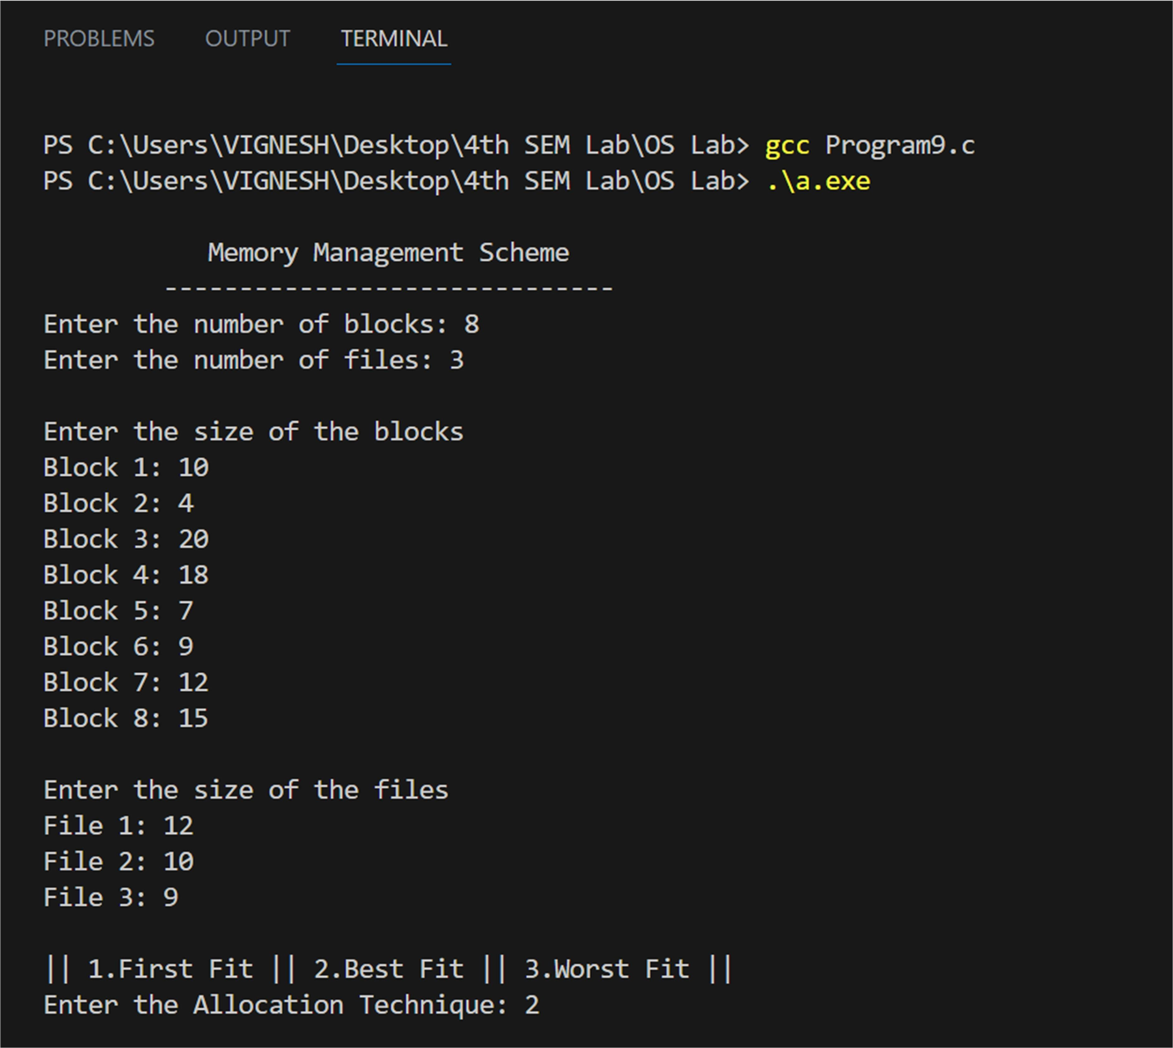

1. **First-Fit**

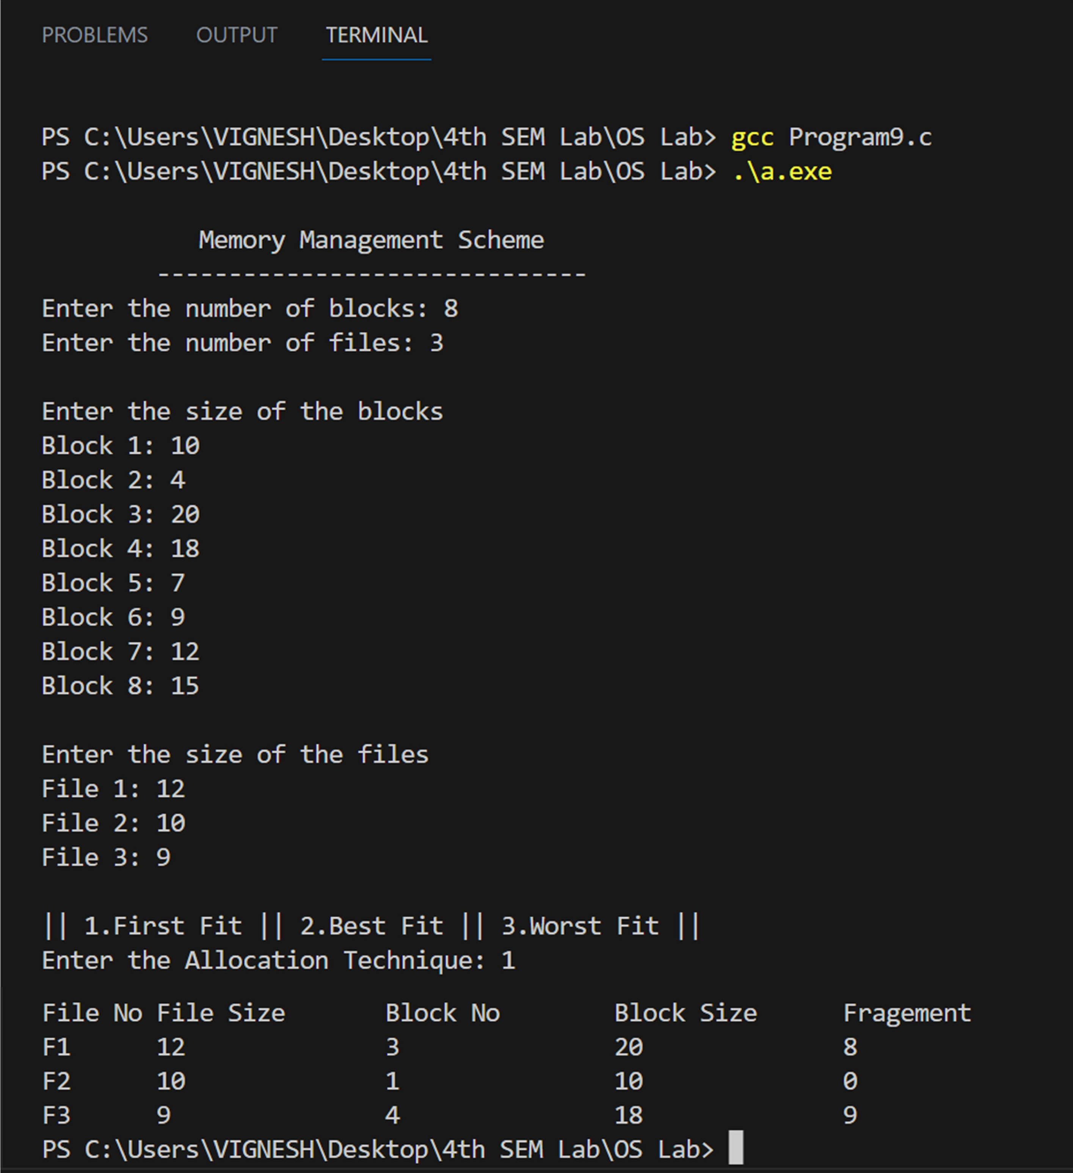

# PROGRAM-10

## Write a C program to simulate paging technique of memory management.

#include <stdio.h> void main()

{

int ms, ps, nop, np, rempages, i, j, x, y, pa, offset; int s[10], fno[10][20];

printf("\nEnter the memory size: "); scanf("%d", &ms);

printf("Enter the page size: "); scanf("%d", &ps);

nop = ms / ps;

printf("\nThe no. of pages available in memory are: %d ", nop);

printf("\nEnter number of processes: "); scanf("%d", &np);

rempages = nop;

for (i = 1; i <= np; i++)

{

printf("\nEnter no. of pages required for P[%d]: ", i); scanf("%d", &s[i]);

if (s[i] > rempages)

{

printf("\nMemory is Full\n"); break;

}

rempages = rempages - s[i];

printf("Enter PageTable for P[%d]: ", i); for (j = 0; j < s[i]; j++)

scanf("%d", &fno[i][j]);

}

printf("\nEnter Logical Address to find Physical Address "); printf("\nEnter Process No. and PageNumber and Offset: ");

scanf("%d %d %d", &x, &y, &offset);

if (x > np || y >= s[i] || offset >= ps)

printf("\nInvalid Process or Page Number or offset\n"); else

{

pa = fno[x][y] * ps + offset;

printf("\nThe Physical Address is: %d", pa);

}

}

# OUTPUT:

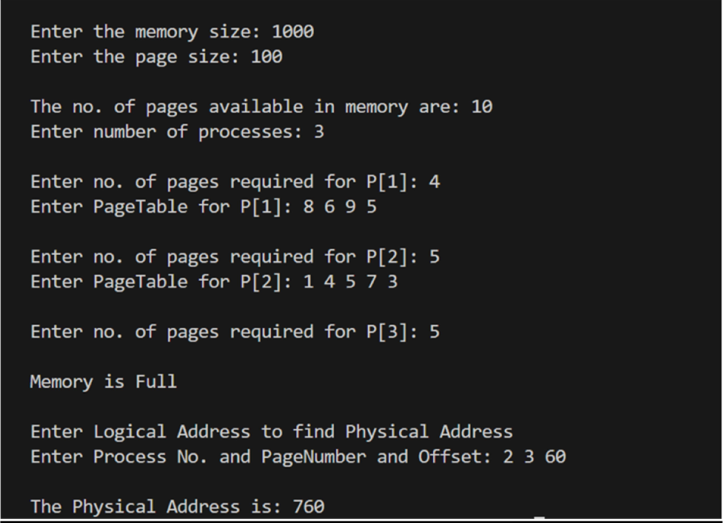

**PROGRAM-11**

## Write a C program to simulate page replacement algorithms

* 1. **FIFO**

## LRU

* 1. **Optimal**

#include <stdio.h>

#define MAX_FRAMES 3

#define MAX_PAGES 20

void fifo(int pages[], int n, int frames)

{

int frame[frames];

int front = 0, rear = 0; int page_faults = 0;

for (int i = 0; i < frames; i++)

{

frame[i] = -1;

}

for (int i = 0; i < n; i++)

{

int found = 0;

for (int j = 0; j < frames; j++)

{

if (frame[j] == pages[i])

{

found = 1; break;

}

}

if (!found)

{

frame[rear] = pages[i]; rear = (rear + 1) % frames; page_faults++;

}

printf("Page %d: ", pages[i]); for (int j = 0; j < frames; j++)

{

if (frame[j] == -1)

printf("- "); else

printf("%d ", frame[j]);

}

printf("\n");

}

printf("Total Page Faults (FIFO): %d\n", page_faults);

}

void lru(int pages[], int n, int frames)

{

int frame[frames]; int page_faults = 0;

int used[MAX_PAGES] = {0};

for (int i = 0; i < frames; i++)

{

frame[i] = -1;

}

for (int i = 0; i < n; i++)

{

int found = 0;

for (int j = 0; j < frames; j++)

{

if (frame[j] == pages[i])

{

found = 1; used[j] = i; break;

}

}

if (!found)

{

int min = 0;

for (int j = 1; j < frames; j++)

{

if (used[j] < used[min])

{

min = j;

}

}

frame[min] = pages[i]; used[min] = i; page_faults++;

}

printf("Page %d: ", pages[i]); for (int j = 0; j < frames; j++)

{

if (frame[j] == -1)

printf("- "); else

printf("%d ", frame[j]);

}

printf("\n");

}

printf("Total Page Faults (LRU): %d\n", page_faults);

}

void optimal (int pages[], int n, int frames)

{

int frame[frames]; int page_faults = 0;

for (int i = 0; i < frames; i++)

{

frame[i] = -1;

}

for (int i = 0; i < n; i++)

{

int found = 0;

for (int j = 0; j < frames; j++)

{

if (frame[j] == pages[i])

{

found = 1; break;

}

}

if (!found)

{

if (i < frames)

{

frame[i] = pages[i];

}

else

{

int max_dist = -1;

int replace_page = -1;

for (int j = 0; j < frames; j++)

{

int dist = MAX_PAGES;

for (int k = i + 1; k < n; k++)

{

if (pages[k] == frame[j])

{

dist = k - i; break;

}

}

if (dist > max_dist)

{

max_dist = dist; replace_page = j;

}

}

frame[replace_page] = pages[i];

}

page_faults++;

}

printf("Page %d: ", pages[i]); for (int j = 0; j < frames; j++)

{

if (frame[j] == -1)

printf("- "); else

printf("%d ", frame[j]);

}

printf("\n");

}

printf("Total Page Faults (Optimal): %d\n", page_faults);

}

int main()

{

int pages[MAX_PAGES]; int n, frames;

printf("Enter the number of pages: "); scanf("%d", &n);

printf("Enter the reference string: "); for (int i = 0; i < n; i++)

{

scanf("%d", &pages[i]);

}

printf("Enter the number of frames: "); scanf("%d", &frames);

printf("\nFIFO Page Replacement:\n"); fifo(pages, n, frames);

printf("\nLRU Page Replacement:\n"); lru(pages, n, frames);

printf("\nOptimal Page Replacement:\n"); optimal(pages, n, frames);

return 0;

}

# OUTPUT:

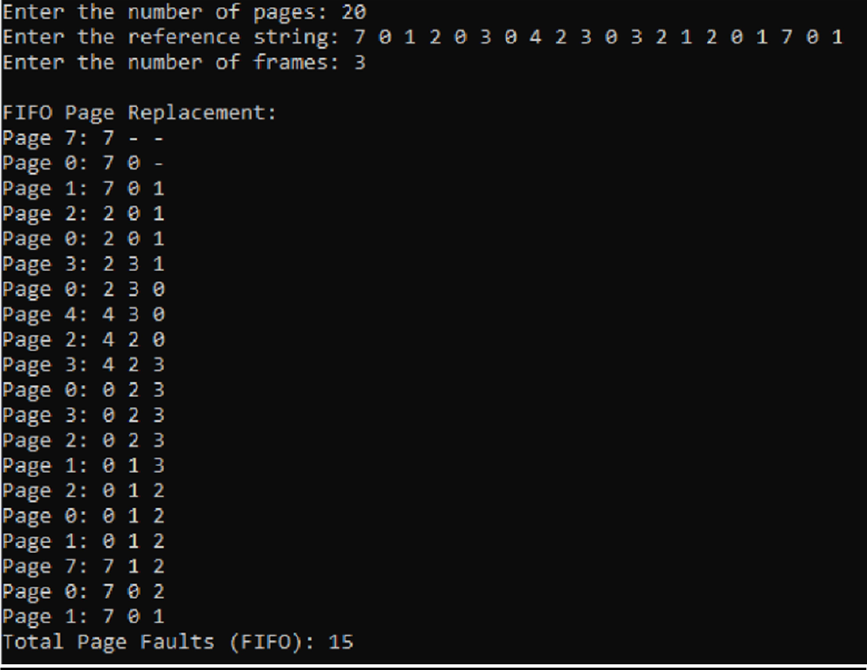

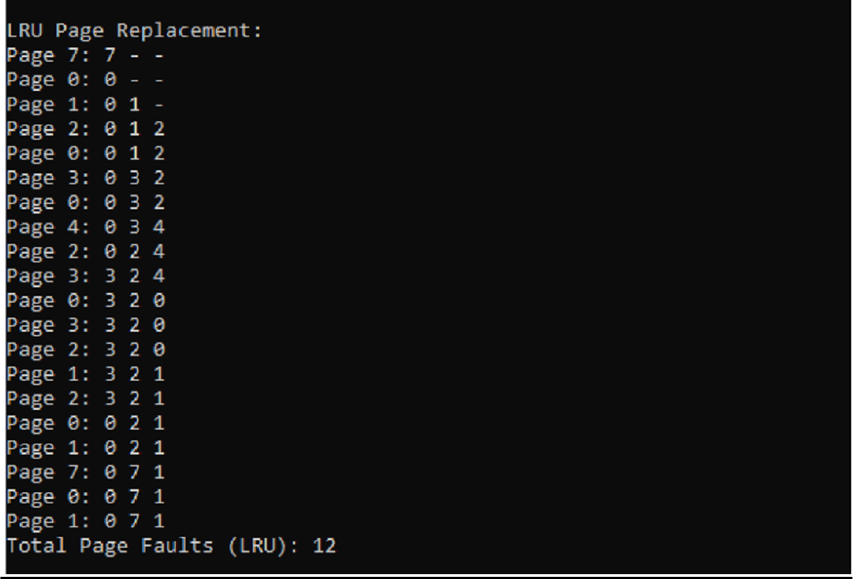

**PROGRAM-12**

## Write a C program to simulate the following file allocation strategies.

1. **Sequential**

## Indexed

1. **Linked**

### Sequential

#include <stdio.h> #include <string.h> #define MAX_FILES 100

#define MAX_FILE_NAME 20 struct File

{

char name[MAX_FILE_NAME]; int startBlock;

int length;

};

struct File fileTable[MAX_FILES]; int totalFiles = 0;

int currentBlock = 0;

void allocateSequential(char *fileName, int length)

{

if (currentBlock + length <= MAX_FILES)

{

strcpy(fileTable[totalFiles].name, fileName); fileTable[totalFiles].startBlock = currentBlock;

fileTable[totalFiles].length = length; currentBlock += length; totalFiles++;

printf("\n>>>File %s allocated sequentially from block %d to %d.\n", fileName, fileTable[totalFiles - 1].startBlock, currentBlock - 1);

}

else

{

printf("\nNot enough space for file allocation.\n");

}

}

int main()

{

int numFiles;

printf("Enter the number of files: "); scanf("%d", &numFiles);

for (int i = 0; i < numFiles; i++)

{

char fileName[MAX_FILE_NAME]; int fileLength;

printf("\nEnter the name of file %d: ", i + 1); scanf("%s", fileName);

printf("Enter the length of file %d: ", i + 1); scanf("%d", &fileLength); allocateSequential(fileName, fileLength);

}

return 0;

}

# OUTPUT:

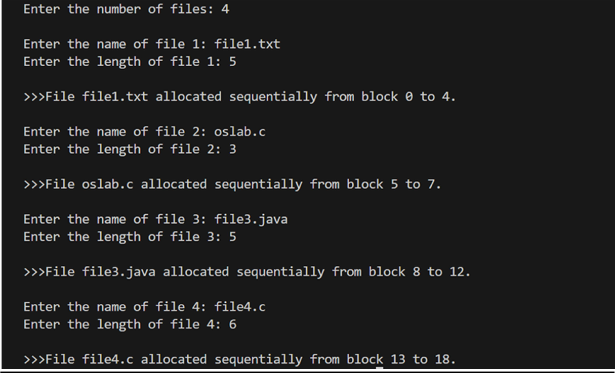

### Indexed

#include <stdio.h> #include <stdlib.h> #include <string.h>

#define MAX_FILES 100

#define MAX_FILE_NAME 20

#define MAX_BLOCKS 100

struct File {

char name[MAX_FILE_NAME]; int indexBlock;

int length;

};

struct File fileTable[MAX_FILES]; int totalFiles = 0;

int currentBlock = 0;

int freeBlocks[MAX_BLOCKS]; // List of free blocks

void initializeFreeBlocks() {

for (int i = 0; i < MAX_BLOCKS; i++) { freeBlocks[i] = 1;

}

}

int allocateBlock() {

for (int i = 0; i < MAX_BLOCKS; i++) {

if (freeBlocks[i]) { freeBlocks[i] = 0; return i;

}

}

return -1; // No free block available

}

void allocateIndexed(char *fileName, int length) { if (totalFiles < MAX_FILES) {

strcpy(fileTable[totalFiles].name, fileName); fileTable[totalFiles].indexBlock = allocateBlock(); fileTable[totalFiles].length = length;

if (fileTable[totalFiles].indexBlock != -1) {

printf(">>>File %s allocated with index block %d\n", fileName, fileTable[totalFiles].indexBlock);

for (int i = 0; i < length; i++) {

int dataBlock = allocateBlock(); if (dataBlock != -1) {

printf(">Data block %d allocated for %s\n", dataBlock, fileName);

} else {

printf("Not enough space for data block allocation.\n"); break;

}

}

totalFiles++;

} else {

printf("\nNot enough space for index block allocation.\n");

}

} else {

printf("\nFile table is full.\n");

}

}

int main() { initializeFreeBlocks(); int numFiles;

printf("Enter the number of files: "); scanf("%d", &numFiles);

for (int i = 0; i < numFiles; i++) {

char fileName[MAX_FILE_NAME]; int fileLength;

printf("\nEnter the name of file %d: ", i + 1); scanf("%s", fileName);

printf("Enter the length of file %d: ", i + 1); scanf("%d", &fileLength);

allocateIndexed(fileName, fileLength);

}

return 0;

}

# OUTPUT:

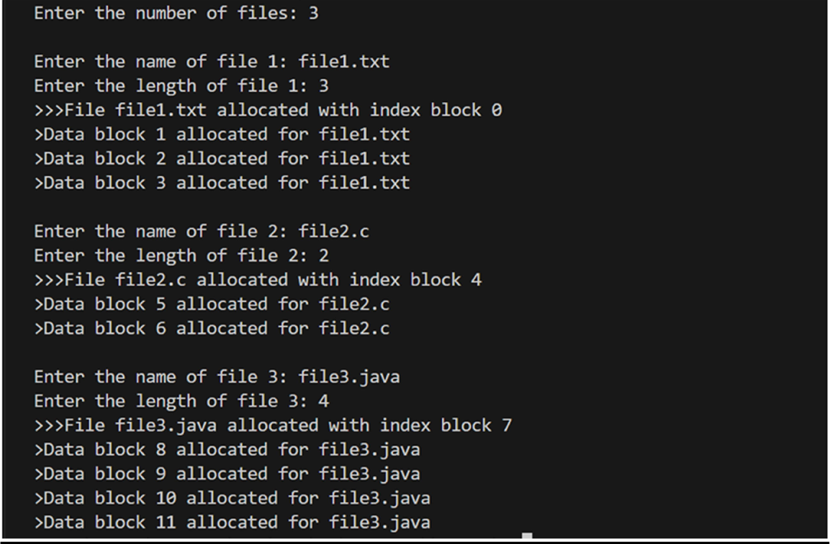

### Linked

#include <stdio.h> #include <stdlib.h>

void main()

{

int f[50], p, i, st, len, j, c, k, a; for (i = 0; i < 50; i++)

f[i] = 0;

printf("\nEnter how many blocks already allocated: "); scanf("%d", &p);

printf("Enter blocks already allocated: "); for (i = 0; i < p; i++)

{

scanf("%d", &a); f[a] = 1;

}

x:

printf("\nEnter index starting block and length: "); scanf("%d%d", &st, &len);

k = len;

if (f[st] == 0)

{

for (j = st; j < (st + k); j++)

{

if (f[j] == 0)

{

f[j] = 1;

printf("%d >%d\n", j, f[j]);

}

else

{

printf("Block %d is already allocated \n", j); k++;

}

}

}

else

printf("%d starting block is already allocated \n", st);

printf("\nDo you want to enter more file(Yes - 1/No - 0)\n>> "); scanf("%d", &c);

if (c == 1) goto x;

else

exit(0);

}

# OUTPUT:

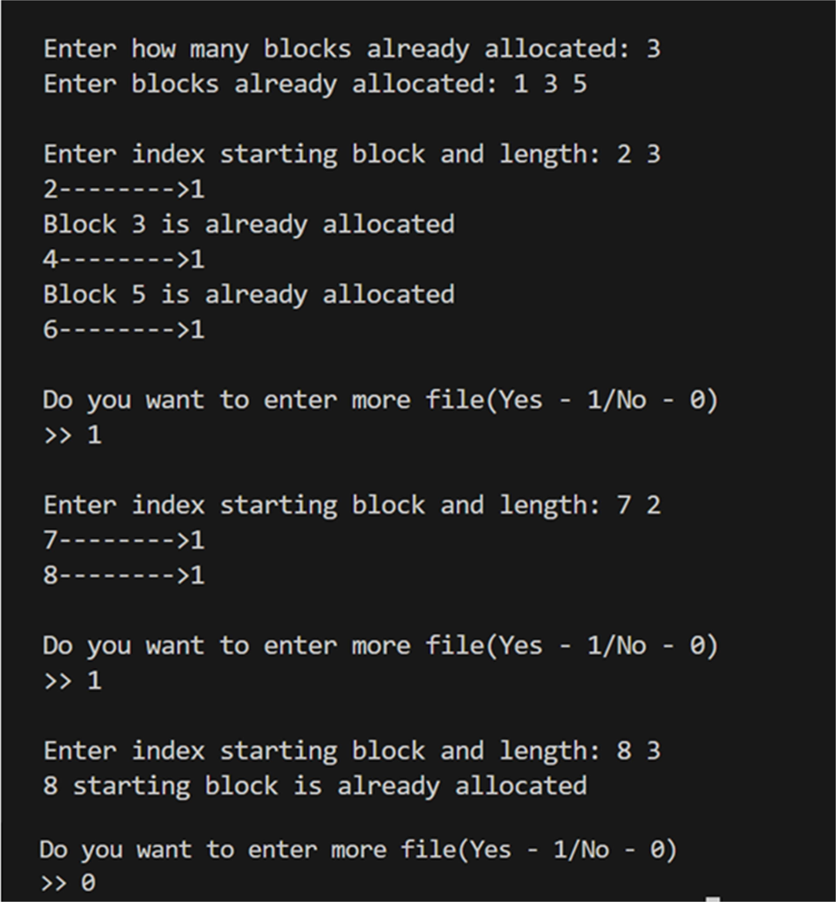

**PROGRAM-13**

## Write a C program to simulate the following file organization techniques

1. **Single level directory**

## Two level directories

1. **Hierarchical**
2. ***Single level directory*** #include <stdio.h> #include <string.h>

void main()

{

int nf = 0, i = 0, j = 0, ch;

char mdname[10], fname[10][10], name[10]; printf("\nEnter the directory name: "); scanf("%s", mdname);

printf("Enter the number of files: "); scanf("%d", &nf);

do

{

printf("\nEnter file name to be created: "); scanf("%s", name);

for (i = 0; i < nf; i++)

{

if (!strcmp(name, fname[i])) break;

}

if (i == nf)

{

strcpy(fname[j++], name); nf++;

}

else

printf("\nFile nam already exits!\n", name);

printf("\nDo you want to enter another file(yes - 1 or no - 0)\n>> "); scanf("%d", &ch);

} while (ch == 1)

printf("\nDirectory name: %s\n", mdname); printf("Files:");

for (i = 0; i < j; i++) printf("\n> %s", fname[i]);

}

# OUTPUT:

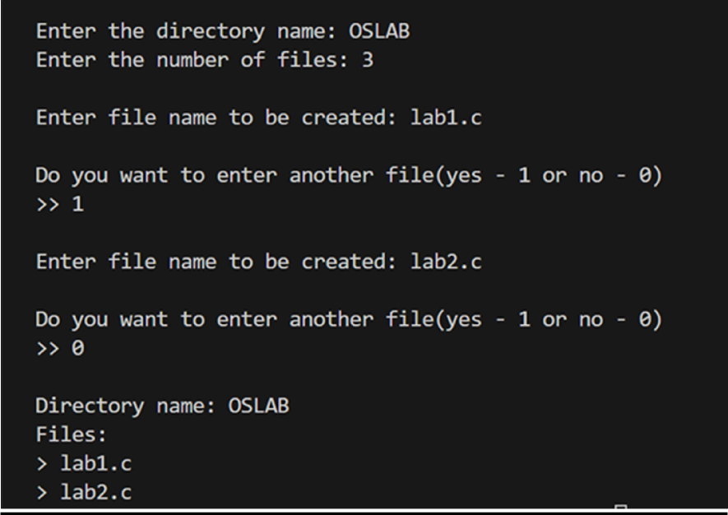

### Two level directories

#include <stdio.h> #include <stdlib.h> #include <string.h>

struct File

{

char name[50];

};

struct UserDirectory

{

char name[50]; struct File files[100]; int fileCount;

};

struct RootDirectory

{

struct UserDirectory users[10]; int userCount;

};

int main()

{

struct RootDirectory rootDir; rootDir.userCount = 0;

int choice;

printf("\nTwo Level Directory\n"); printf("1. Create User Directory\n"); printf("2. Create File\n");

printf("3. List Files\n"); printf("4. Exit\n");

do

{

printf("\nEnter your choice: "); scanf("%d", &choice);

switch (choice)

{

case 1:

if (rootDir.userCount < 10)

{

printf("Enter user name: ");

scanf("%s", rootDir.users[rootDir.userCount].name); rootDir.users[rootDir.userCount].fileCount = 0; rootDir.userCount++;

printf(">User directory created.\n");

}

else

{

printf(">User directory limit reached.\n");

}

break;

case 2:

if (rootDir.userCount > 0)

{

printf("Enter user index: "); int userIndex;

scanf("%d", &userIndex);

if (userIndex >= 0 && userIndex < rootDir.userCount)

{

struct UserDirectory *userDir = &rootDir.users[userIndex]; if (userDir->fileCount < 100)

{

printf("Enter file name: ");

scanf("%s", userDir->files[userDir->fileCount].name); userDir->fileCount++;

printf(">File created.\n");

}

else

{

printf(">User directory is full.\n");

}

}

else

{

printf(">Invalid user index.\n");

}

}

else

{

printf(">No user directories available.\n");

}

break; case 3:

printf("Files in user directories:\n");

for (int i = 0; i < rootDir.userCount; i++)

{

struct UserDirectory *userDir = &rootDir.users[i]; printf("User: %s\n", userDir->name);

for (int j = 0; j < userDir->fileCount; j++)

{

printf(" %s\n", userDir->files[j].name);

}

}

break; case 4:

printf("Exiting...\n"); break;

default:

printf("Invalid choice.\n");

}

} while (choice != 4);

return 0;

}

# OUTPUT:

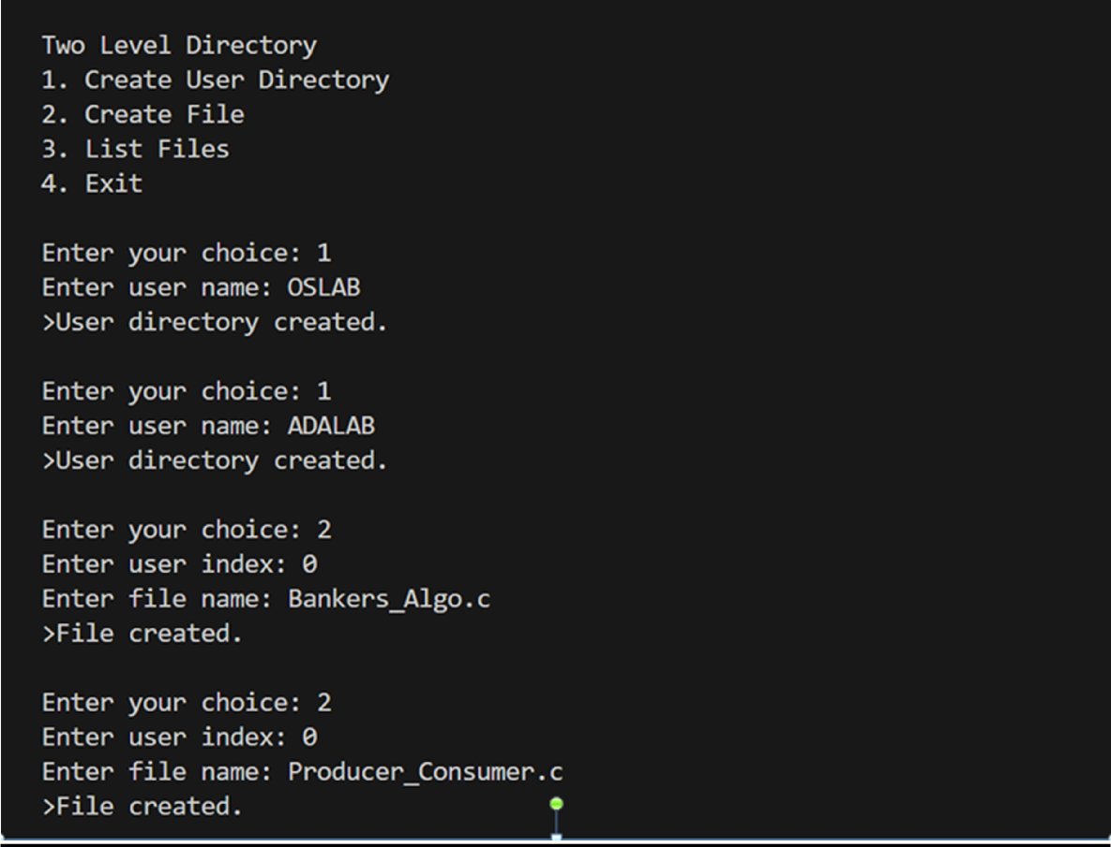

### Hierarchical

#include <stdio.h> #include <stdlib.h> #include <string.h>

struct File

{

char name[50];

};

struct Directory

{

char name[50]; struct File files[100]; int fileCount;

struct Directory *subdirectories[10]; int subdirCount;

};

void createSubdirectory(struct Directory *parentDir)

{

if (parentDir->subdirCount < 10)

{

struct Directory *subDir = (struct Directory *)malloc(sizeof(struct Directory)); printf("Enter subdirectory name: ");

scanf("%s", subDir->name); subDir->fileCount = 0;

subDir->subdirCount = 0;

parentDir->subdirectories[parentDir->subdirCount] = subDir; parentDir->subdirCount++;

printf("Subdirectory created.\n");

}

else

{

printf("Subdirectory limit reached.\n");

}

}

int main()

{

struct Directory rootDir; strcpy(rootDir.name, "Root"); rootDir.fileCount = 0;

rootDir.subdirCount = 0;

int choice;

printf("\nHierarchical Directory\n"); printf("1. Create Subdirectory\n"); printf("2. Create File\n");

printf("3. List Files and Directories\n"); printf("4. Exit\n");

do

{

printf("\nEnter your choice: "); scanf("%d", &choice);

switch (choice)

{

case 1:

createSubdirectory(&rootDir); break;

case 2:

printf("Enter directory name: "); char dirName[50];

scanf("%s", dirName);

struct Directory *targetDir = NULL;

for (int i = 0; i < rootDir.subdirCount; i++)

{

if (strcmp(rootDir.subdirectories[i]->name, dirName) == 0)

{

targetDir = rootDir.subdirectories[i]; break;

}

}

if (targetDir != NULL)

{

if (targetDir->fileCount < 100)

{

printf("Enter file name: ");

scanf("%s", targetDir->files[targetDir->fileCount].name); targetDir->fileCount++;

printf("File created.\n");

}

else

{

printf("Directory is full.\n");

}

}

else

{

printf("Directory not found.\n");

}

break; case 3:

printf("Files and subdirectories:\n"); printf("Root:\n");

for (int i = 0; i < rootDir.subdirCount; i++)

{

printf(" %s (directory)\n", rootDir.subdirectories[i]->name);

for (int j = 0; j < rootDir.subdirectories[i]->fileCount; j++)

{

printf(" %s (file)\n", rootDir.subdirectories[i]->files[j].name);

}

}

for (int i = 0; i < rootDir.fileCount; i++)

{

printf(" %s (file)\n", rootDir.files[i].name);

}

break; case 4:

printf("Exiting...\n"); break;

default:

printf("Invalid choice.\n");

}

} while (choice != 4);

return 0;

}

# OUTPUT:

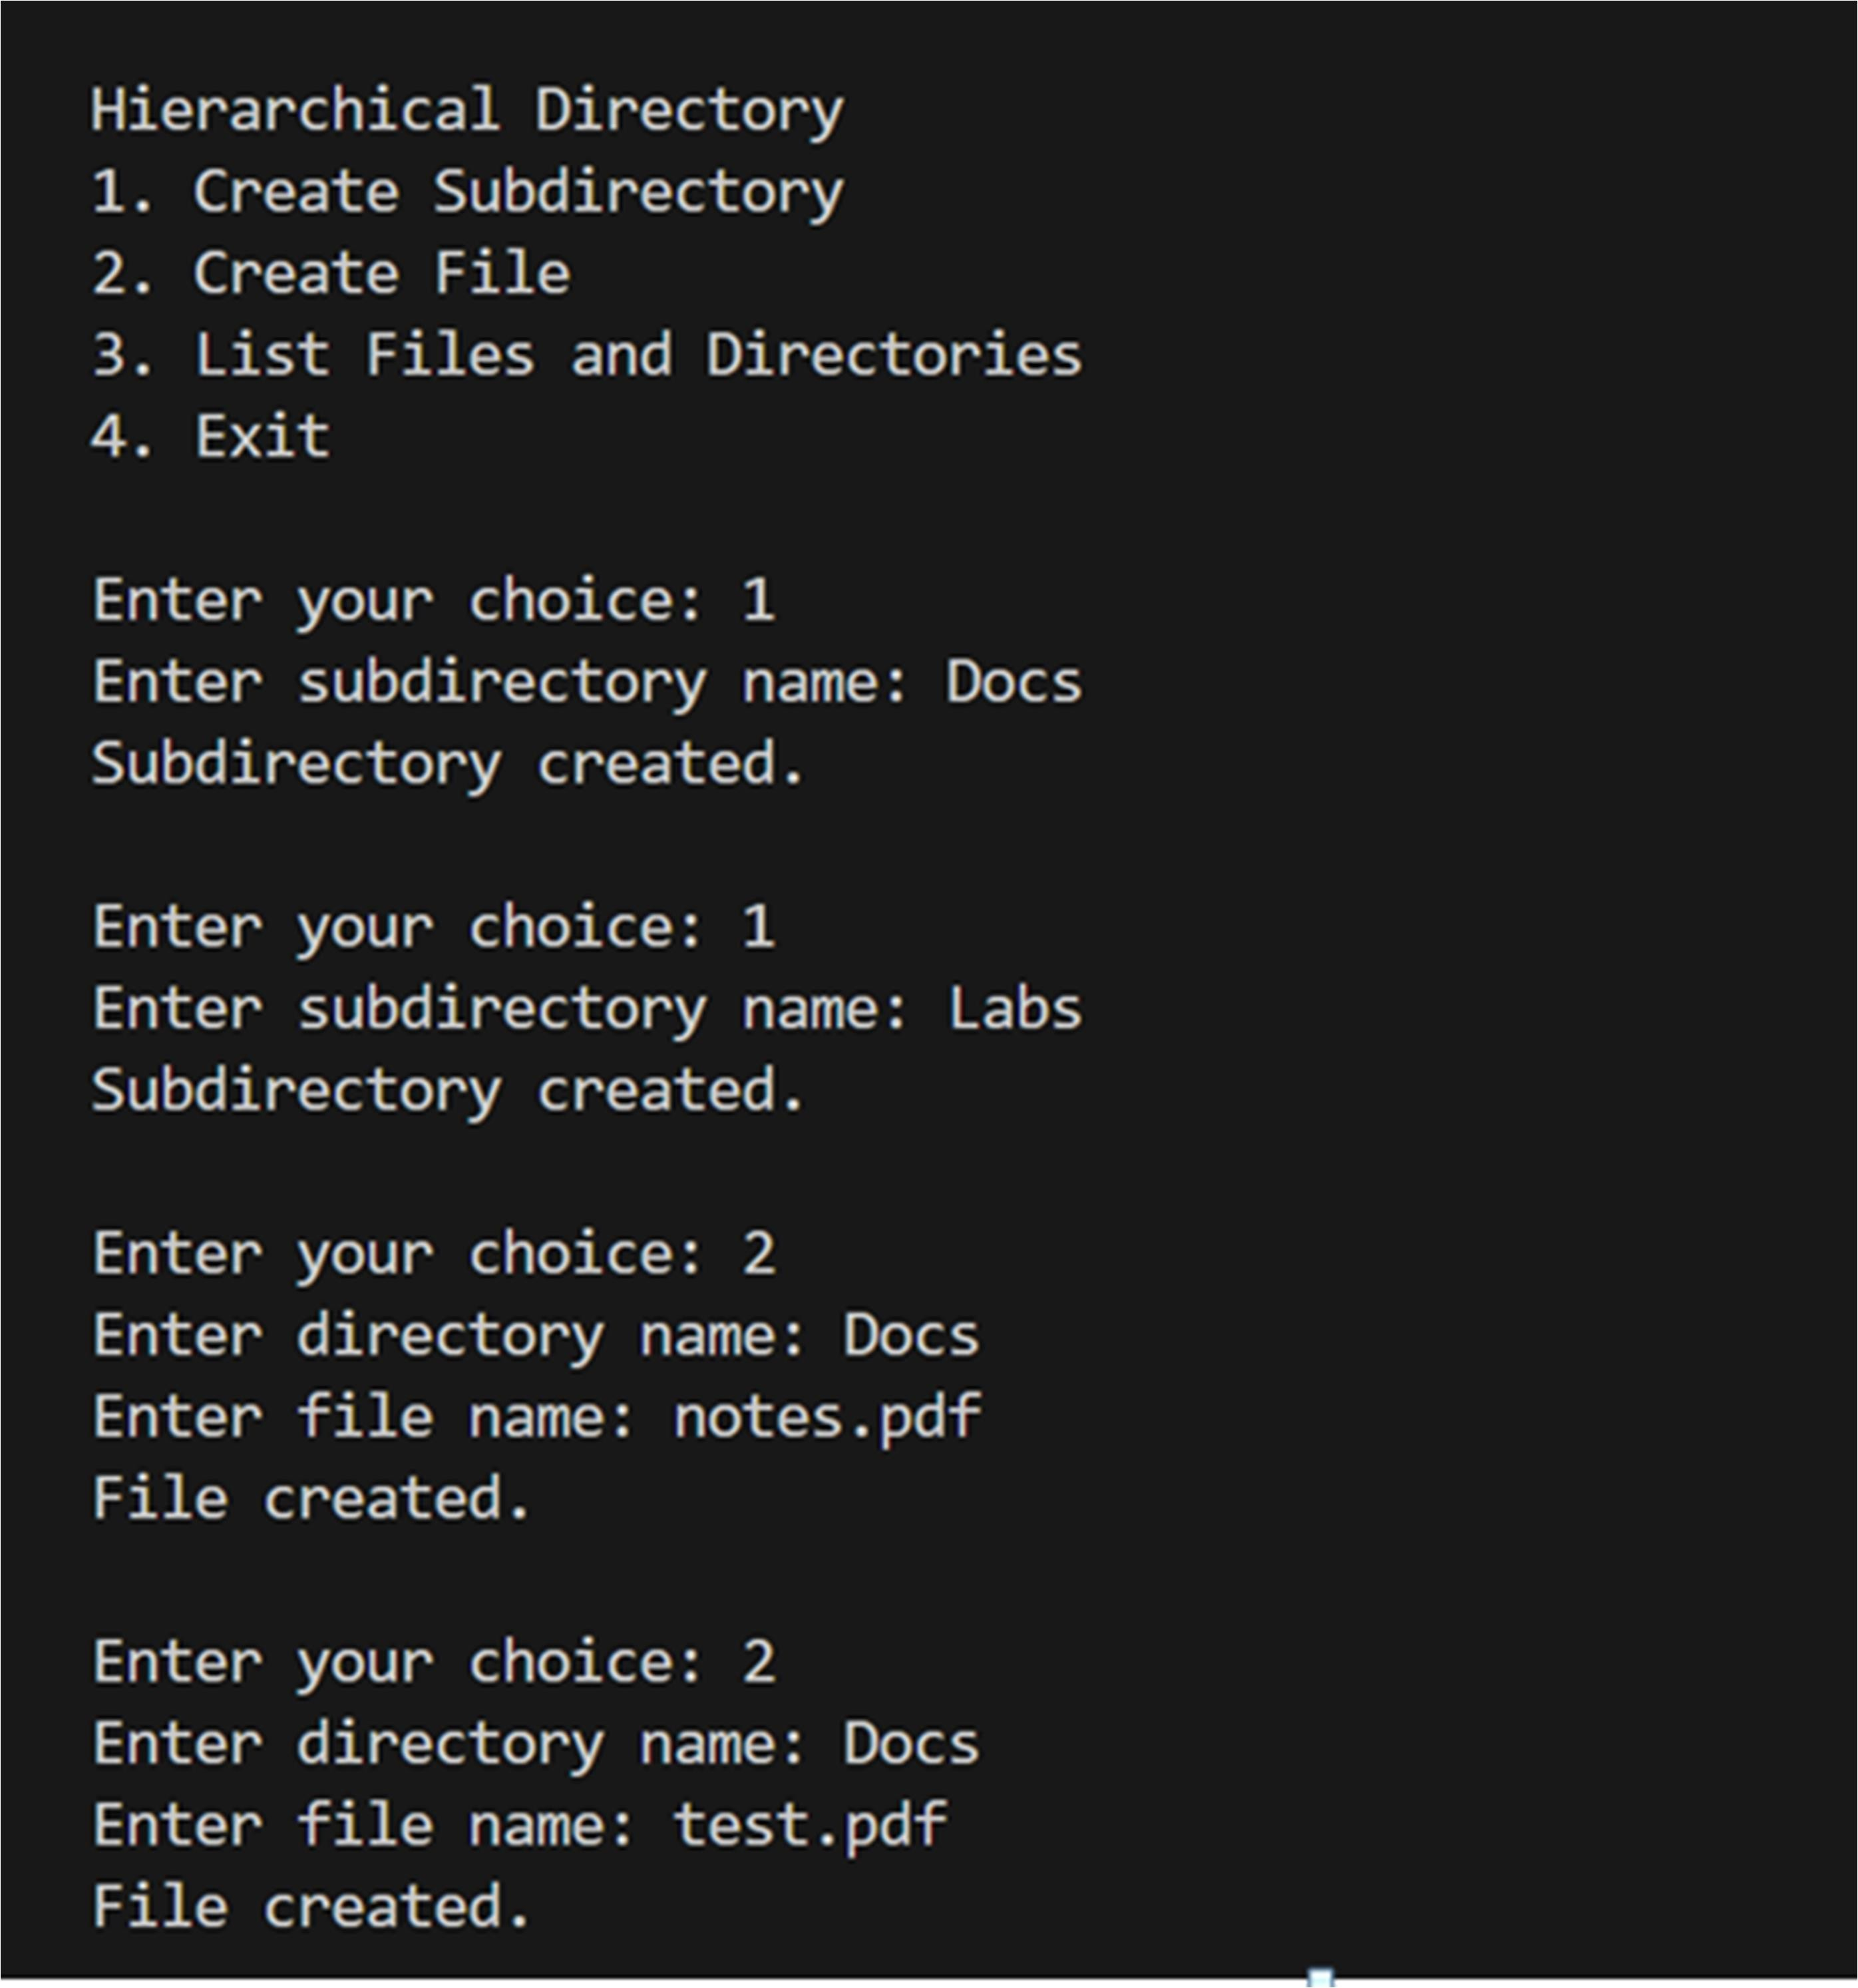

**PROGRAM-14**

## Write a C program to simulate disk scheduling algorithms

1. **FCFS**

## SCAN

1. **C-SCAN**

#include <stdio.h> #include <stdlib.h>

void FCFS()

{

int RQ[100], i, n, TotalHeadMoment = 0, initial; printf("\n>>> FCFS Algorithm <<<"); printf("\nEnter the number of Requests: "); scanf("%d", &n);

printf("Enter the Requests sequence: "); for (i = 0; i < n; i++)

scanf("%d", &RQ[i]);

printf("Enter initial head position: "); scanf("%d", &initial);

for (i = 0; i < n; i++)

{

TotalHeadMoment = TotalHeadMoment + abs(RQ[i] - initial); initial = RQ[i];

}

printf("Total head moment is: %d", TotalHeadMoment);

}

void SCAN()

{

int RQ[100], i, j, n, TotalHeadMoment = 0, initial, size, move; printf("\n>>> SCAN Algorithm <<<");

printf("\nEnter the number of Requests: "); scanf("%d", &n);

printf("Enter the Requests sequence: "); for (i = 0; i < n; i++)

scanf("%d", &RQ[i]);

printf("Enter initial head position: "); scanf("%d", &initial);

printf("Enter total disk size: "); scanf("%d", &size);

printf(">>Choose the head movement direction\n>0.Towards the smaller value\n>1.Towards the larger value\n>>: ");

scanf("%d", &move);

for (i = 0; i < n; i++)

{

for (j = 0; j < n - i - 1; j++)

{

if (RQ[j] > RQ[j + 1])

{

int temp; temp = RQ[j];

RQ[j] = RQ[j + 1];

RQ[j + 1] = temp;

}

}

}

int index;

for (i = 0; i < n; i++)

{

if (initial < RQ[i])

{

index = i; break;

}

}

if (move == 1)

{

for (i = index; i < n; i++)

{

TotalHeadMoment = TotalHeadMoment + abs(RQ[i] - initial); initial = RQ[i];

}

TotalHeadMoment = TotalHeadMoment + abs(size - RQ[i - 1] - 1); initial = size - 1;

for (i = index - 1; i >= 0; i--)

{

TotalHeadMoment = TotalHeadMoment + abs(RQ[i] - initial); initial = RQ[i];

}

}

else

{

for (i = index - 1; i >= 0; i--)

{

TotalHeadMoment = TotalHeadMoment + abs(RQ[i] - initial); initial = RQ[i];

}

TotalHeadMoment = TotalHeadMoment + abs(RQ[i + 1] - 0); initial = 0;

for (i = index; i < n; i++)

{

TotalHeadMoment = TotalHeadMoment + abs(RQ[i] - initial); initial = RQ[i];

}

}

printf("Total head movement is: %d", TotalHeadMoment);

}

void C_SCAN()

{

int RQ[100], i, j, n, TotalHeadMoment = 0, initial, size, move;

printf("\n>>> C-SCAN Algorithm <<<"); printf("\nEnter the number of Requests: "); scanf("%d", &n);

printf("Enter the Requests sequence: ");

for (i = 0; i < n; i++) scanf("%d", &RQ[i]);

printf("Enter initial head position: "); scanf("%d", &initial);

printf("Enter total disk size: "); scanf("%d", &size);

printf(">>Choose the head movement direction\n>0.Towards the smaller value\n>1.Towards the larger value\n>>: ");

scanf("%d", &move);

for (i = 0; i < n; i++)

{

for (j = 0; j < n - i - 1; j++)

{

if (RQ[j] > RQ[j + 1])

{

int temp; temp = RQ[j];

RQ[j] = RQ[j + 1];

RQ[j + 1] = temp;

}

}

}

int index;

for (i = 0; i < n; i++)

{

if (initial < RQ[i])

{

index = i; break;

}

}

if (move == 1)

{

for (i = index; i < n; i++)

{

TotalHeadMoment = TotalHeadMoment + abs(RQ[i] - initial); initial = RQ[i];

}

TotalHeadMoment = TotalHeadMoment + abs(size - RQ[i - 1] - 1); TotalHeadMoment = TotalHeadMoment + abs(size - 1 - 0);

initial = 0;

for (i = 0; i < index; i++)

{

TotalHeadMoment = TotalHeadMoment + abs(RQ[i] - initial); initial = RQ[i];

}

}

else

{

for (i = index - 1; i >= 0; i--)

{

TotalHeadMoment = TotalHeadMoment + abs(RQ[i] - initial); initial = RQ[i];

}

TotalHeadMoment = TotalHeadMoment + abs(RQ[i + 1] - 0); TotalHeadMoment = TotalHeadMoment + abs(size - 1 - 0); initial = size - 1;

for (i = n - 1; i >= index; i--)

{

TotalHeadMoment = TotalHeadMoment + abs(RQ[i] - initial); initial = RQ[i];

}

}

printf("Total head movement is: %d", TotalHeadMoment);

}

void main()

{

int ch;

printf("\nDisk Scheduling Algorithms"); while (1)

{

printf("\n\nChoose an Algorithm\n"); printf("1.FCFS\n2.SCAN\n3.C-SCAN\n4.EXIT");

printf("\n>>Enter your choice: "); scanf("%d", &ch);

switch (ch)

{

case 1:

FCFS();

break;

case 2:

SCAN();

break; case 3:

C_SCAN();

break; case 4:

exit(0); default:

printf("Invalid choice\n");

}

}

}

# OUTPUT:

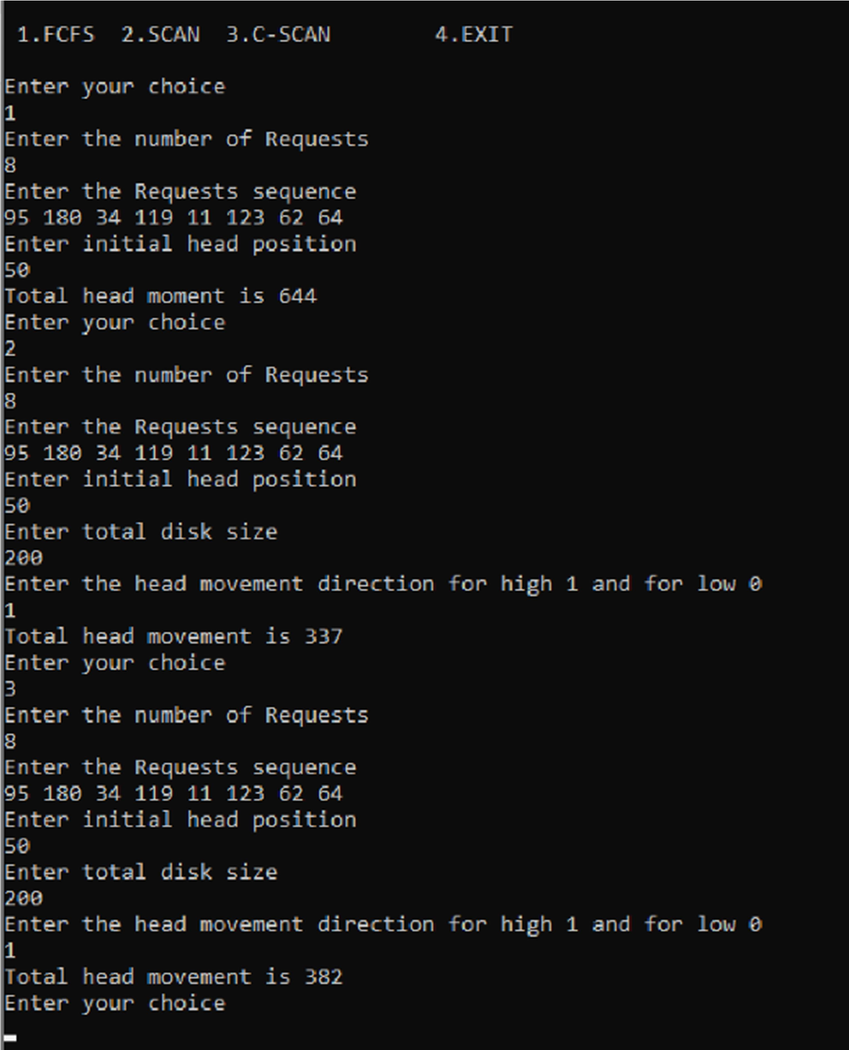

**PROGRAM-15**

## Write a C program to simulate disk scheduling algorithms

1. **SSTF**

## LOOK

1. **c-LOOK**

#include <stdio.h> #include <stdlib.h>

void SSTF()

{

int RQ[100], i, n, TotalHeadMoment = 0, initial, count = 0; printf("\n>>> SSTF Algorithm <<<");

printf("\nEnter the number of Requests: "); scanf("%d", &n);

printf("Enter the Requests sequence: "); for (i = 0; i < n; i++)

scanf("%d", &RQ[i]); printf("Enter initial head position: "); scanf("%d", &initial);

while (count != n)

{

int min = 1000, d, index; for (i = 0; i < n; i++)

{

d = abs(RQ[i] - initial); if (min > d)

{

min = d; index = i;

}

}

TotalHeadMoment = TotalHeadMoment + min; initial = RQ[index];

RQ[index] = 1000; count++;

}

printf("Total head movement is: %d", TotalHeadMoment);

}

void LOOK()

{

int RQ[100], i, j, n, TotalHeadMoment = 0, initial, size, move; printf("\n>>> LOOK Algorithm <<<");

printf("\nEnter the number of Requests: "); scanf("%d", &n);

printf("Enter the Requests sequence: "); for (i = 0; i < n; i++)

scanf("%d", &RQ[i]); printf("Enter initial head position: "); scanf("%d", &initial);

printf(">>Choose the head movement direction\n>0.Towards the smaller value\n>1.Towards the larger value\n>>: ");

scanf("%d", &move);

for (i = 0; i < n; i++)

{

for (j = 0; j < n - i - 1; j++)

{

if (RQ[j] > RQ[j + 1])

{

int temp; temp = RQ[j];

RQ[j] = RQ[j + 1];

RQ[j + 1] = temp;

}

}

}

int index;

for (i = 0; i < n; i++)

{

if (initial < RQ[i])

{

index = i; break;

}

}

if (move == 1)

{

for (i = index; i < n; i++)

{

TotalHeadMoment = TotalHeadMoment + abs(RQ[i] - initial);

initial = RQ[i];

}

for (i = index - 1; i >= 0; i--)

{

TotalHeadMoment = TotalHeadMoment + abs(RQ[i] - initial); initial = RQ[i];

}

}

else

{

for (i = index - 1; i >= 0; i--)

{

TotalHeadMoment = TotalHeadMoment + abs(RQ[i] - initial); initial = RQ[i];

}

for (i = index; i < n; i++)

{

TotalHeadMoment = TotalHeadMoment + abs(RQ[i] - initial); initial = RQ[i];

}

}

printf("Total head movement is: %d", TotalHeadMoment);

}

void C_LOOK()

{

int RQ[100], i, j, n, TotalHeadMoment = 0, initial, size, move;

printf("\n>>> C-LOOK Algorithm <<<"); printf("\nEnter the number of Requests: "); scanf("%d", &n);

printf("Enter the Requests sequence: "); for (i = 0; i < n; i++)

scanf("%d", &RQ[i]); printf("Enter initial head position: "); scanf("%d", &initial);

printf(">>Choose the head movement direction\n>0.Towards the smaller value\n>1.Towards the larger value\n>>: ");

scanf("%d", &move);

for (i = 0; i < n; i++)

{

for (j = 0; j < n - i - 1; j++)

{

if (RQ[j] > RQ[j + 1])

{

int temp; temp = RQ[j];

RQ[j] = RQ[j + 1];

RQ[j + 1] = temp;

}

}

}

int index;

for (i = 0; i < n; i++)

{

if (initial < RQ[i])

{

index = i; break;

}

}

if (move == 1)

{

for (i = index; i < n; i++)

{

TotalHeadMoment = TotalHeadMoment + abs(RQ[i] - initial); initial = RQ[i];

}

for (i = 0; i < index; i++)

{

TotalHeadMoment = TotalHeadMoment + abs(RQ[i] - initial); initial = RQ[i];

}

}

else

{

for (i = index - 1; i >= 0; i--)

{

TotalHeadMoment = TotalHeadMoment + abs(RQ[i] - initial); initial = RQ[i];

}

for (i = n - 1; i >= index; i--)

{

TotalHeadMoment = TotalHeadMoment + abs(RQ[i] - initial); initial = RQ[i];

}

}

printf("Total head movement is: %d", TotalHeadMoment);

}

void main()

{

int ch;

printf("\nDisk Scheduling Algorithms"); while (1)

{

printf("\n\nChoose an Algorithm\n"); printf("1.SSTF\n2.LOOK\n3.C-LOOK\n4.EXIT");

printf("\n>>Enter your choice: "); scanf("%d", &ch);

switch (ch)

{

case 1:

SSTF();

break; case 2:

LOOK();

break; case 3:

C_LOOK();

break; case 4:

exit(0); default:

printf("Invalid choice\n");

}

}

}

# OUTPUT:

